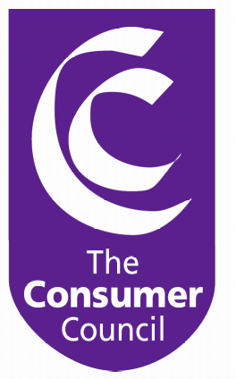

Submission to

Department for Regional Development

on

The Reform of Water and Sewerage Services in Northern Ireland

Integrated Impact Assessment

March 2005

Contents

Introduction

Integrated Impact Assessment – General Points

Response to Integrated Impact Assessment Overview

Response to Equality Impact Assessment

Response to Partial Regulatory Impact Assessment

The Consumer Council’s Additional Impact Assessments

Water – A Clear Way Forward
8. Main Findings and Conclusions

Annex A: Independent Consumer Research, October 2004
ATTACHED:
Analysis Report: Water – A Clear Way Forward

1. Introduction

About Our Response

The General Consumer Council for Northern Ireland (The Consumer Council) is a statutory body established in 1985 with the general duty to promote and protect the interests of consumers. The Consumer Council aims to make the consumer voice heard and to make it count. Our response to the Integrated Impact Assessment (IIA) on the Government’s proposals for reform of water and sewerage services in Northern Ireland is of particular relevance as The Consumer Council has been proposed as the consumer representative organisation for water and sewerage services.

It is our view that an open, transparent and informed debate needs to take place on how much is needed to improve and maintain all our public services and infrastructure, including water and sewerage. Agreement needs to be reached on how the cost of quality services should be met and contributed to appropriately by the Government, the private sector and the general public, and how the most vulnerable and disadvantaged in our society are protected from increased costs.

In the absence of such a wide debate, the Government has indicated its proposals for reforming water and sewerage services in Northern Ireland with the planned introduction of a separate water charge from April 2006 onwards or as near to that date as practicable.

It is in this current legislative context that this response is made. Within this consultation period the Consumer Council is seeking to ensure that the introduction of direct water and sewerage service charges are fair, affordable and sustainable for all consumers; that they fully reflect the particular circumstances, needs and costs within Northern Ireland; and that they draw on models of best practice throughout Europe and beyond.

This response seeks to:
- Comment on the Government’s impact assessments on the policy proposals and address specific queries posed within the suite of documents published on 29 November 2004; (Sections 2 – 5)
- Illustrate further impacts for the Government to take full account of within their policy development and preparation of draft legislation which is due to be consulted on in 2005; (Section 6)
- Comment on the current Water Reform policy proposals and suggest changes to reflect fair, affordable and sustainable solutions. (Section 7)
Our submission reflects results from unique independent consumer research carried out for the Consumer Council in August 2002, and updated in October 2004. It also encompasses ongoing public formal and informal feedback from a wide range of consumers and key stakeholders, as well as analysis carried out with help from many with specialist knowledge and interest in this area. Our sincere thanks are extended to all who helped for their support, expertise and feedback.

This document is produced in conjunction with our Analysis Report: Water – A Clear Way Forward which is attached. A summary is contained in Section 7 of this paper.

Please note that some points are repeated or cross-referenced in several places within our response as they are applicable to different aspects of the IIA.

Context of Response

The right to an adequate supply of safe, wholesome water is a basic human right. Water is a fundamental requirement of public health and hygiene. Similarly, a modern, safe and effective sewerage system is essential for us and the environment for today and tomorrow. Water differs from other utilities such as electricity or telecommunications. This is demonstrated in the fact that there are to be no domestic disconnections from the water supply here, and it is against the law to do so in Great Britain, except in exceptional circumstances such as blatant misuse or potential cross contamination of water supplies.

It is true that we enjoy plenty of rain in Northern Ireland. But it does not follow that the quality water coming out of our taps is therefore a free resource. Rainwater goes through many costly processes to treat, store and pipe it to our homes as well as to ensure that waste water is safely piped away, treated and disposed of. Furthermore, although our water supplies are relatively high compared to other areas within the UK and Europe it is projected that increasing demands and increasing populations will lead to a 20 per cent shortfall in water supply by 2030.

Few would argue that Northern Ireland needs to increase investment in public services and infrastructure to meet its population’s requirements now and in the future. Over the decades there has been a steady decline in the quality of many of our public services and infrastructure, including water and sewerage, which makes it increasingly difficult for quality standards and EU legislative requirements to be met. High quality public services such as education and health and improved infrastructure for water, sewerage and public transport all come at a cost.

The Consumer Council has been consistent in supporting the principle of paying for water while recognising that most of us would rather not pay more from very overstretched and hard earned incomes and benefits. Many are fearful that they will struggle to afford to pay an additional household bill. Therefore, there has also been consistency in our view that any proposed new way must be:
- Fair (i.e. value for money for those who can afford to pay)
- Affordable (i.e. not causing hardship to those who cannot afford to pay)
- Sustainable (i.e. a secure and sustainable funding stream and encourages efficient use of water resources).

The Consumer Council recognises the number of drivers for change within the Water Reform programme including:
- securing compliance with EU legislation including introduction of direct charging for water by 2010, and encouraging efficient use of water;
- increasing quality standards of our drinking water;
- improving treatment and disposal of sewage and waste water;
- increasing the levels of revenue available to fund future water and sewerage services and infrastructure requirements; and
- making monies available to meet the increasing funding needs of other public services and infrastructure such as hospitals, schools, roads etc.
The fact is that in every society consumers pay for water in one way or another. Some countries pay for their water through general taxation, local taxation or a combination of both. More commonly throughout Europe and most of the developed world these services and infrastructure are totally or partially funded through some form of direct water charging.
Northern Ireland is no different in this respect. We already pay for water and sewerage services and infrastructure through our rates and general taxation. In 1999, each household here paid £127 towards the cost within their overall rates bill. Any charging system must adhere to the principles of being fair and affordable for all, providing adequate protection for those who genuinely cannot afford to pay, and encouraging us to use our water resource wisely and efficiently now and in the future.
Therefore the debate needs to be framed around some key questions for us all, including: How much do we already pay? How much more do we need to pay? Is the £3bn investment programme cost-reflective and efficient or is it gold plated or inefficient? What is the best way of paying? How efficient are our water and sewerage services? How do we protect those who cannot afford to pay against the impact of the total household bill of water charges and rates?

The Consumer Council is growing increasingly concerned with the unyielding timescales for the introduction of far-reaching reforms and the implementation of very complex charging and structural charging which will impact on every person and household across Northern Ireland for many years to come. The Government must allow the necessary time to get these new and controversial reforms right for all – consumers, businesses, Government, Treasury and Europe.

It is vital that the Government allows space and time to openly and fully consider the comments, additional identified impacts and suggested changes being proposed by The Consumer Council and others within this debate.

Good policy decisions and robust legislation are best built on a fully informed debate, which promotes engagement and general agreement on the best way forward. The Government has a unique opportunity to engage positively with all interested parties with common purpose. Focus must be placed on the particular needs, circumstances and revenue requirements within Northern Ireland, rather than in comparison with the rest of the United Kingdom. Each jurisdiction should take responsibility for identifying and raising the funding needed to deliver quality, efficient water and sewerage services required by users as well as EU legislation.

A Clear Way Forward
The Consumer Council believes that many reasonable concerns have been raised in this and other submissions to the Integrated Impact Assessment consultation. It will be important that the Government outlines a clear process for addressing outstanding issues. A new timeline for consideration and finalisation of impact assessments alongside the introduction of water charges and transitional arrangements must be announced as soon as possible to allow for a considered period of planning and policy development in light of evidence and research.

2. Integrated Impact Assessment - General Points

While the Consumer Council has endeavoured to respond fully to the Integrated Impact Assessment (IIA) our submission has been constrained due to several factors:

- The IIA, and in particular the EqIA, does not fully assess the impact of the core elements of its policy proposals which will affect all 669,000 households here:
  - Critically, the proposal to charge all domestic consumers of water and sewerage services on the basis of a fixed charge and capital value is not jointly and holistically assessed;
  - The proposal to provide 25 per cent discount for vulnerable and disadvantaged groups is not assessed in terms of the potential effect of this policy on debt, poverty, hardship, health and wellbeing;
  - The screening decision to not subject the policy proposals to health impact assessment is defective since access to adequate supplies of clean and safe water is a central public health and hygiene issue; and
  - It is difficult to understand the rationale behind omitting disability groups from impact assessment. This needs to be reconsidered.
- The IIA requires consultees to respond to the assessed impacts of the
water reform policies as opposed to the policies themselves. The absence of a fully informed and open debate on how we are going to ensure that water and sewerage services and infrastructure here are adequately funded and paid for now and in the future has contributed in part to a lack of widespread public “buy-in” to the water reform programme;
- The IIA consultation has taken place without key information which limits all consultees’ ability to reflect fully on, and respond comprehensively to, the proposals and their impacts.
  - Firstly, the Northern Ireland Asset Management Plan (NIAMP2) has only been made available from 2 February 2005 on the Water Service website (www.waterni.gov.uk). It is questionable if the general public, their representatives and interested parties central to this important consultation are aware of and/or understand the significance of this Plan to the Water Reform proposals. Although technical in its nature, the Government has a responsibility to clearly outline and explain the Plan and its implications widely to inform the debate.
  - Secondly, Northern Ireland consumers are still awaiting the Strategic Financial Review that is being carried out at present, and is due to be completed in the near future. This Review is a necessary element of the overall debate and, critically, emerging policy developments and decisions.
  - The Government has yet to clearly explain the rationale and evidence underlying all its policy proposals. Outlining the option analysis and decision making behind the water reform programme would, in our opinion, provide the Government with a real opportunity to secure broader understanding.

- The Government’s Water Reform proposals continue to attract widespread opposition and unease and do not enjoy confidence or support by consumers, their representatives and key interested parties. More debate, information and clarity is needed to allow full consideration of the issues and agree on a clear way forward to meet the needs of all.
For example, the public largely believe that they pay for water through their rates bill (see Figure 1). Research carried out by The Consumer Council in October 2004 showed that when asked what people thought their rates contributed towards, ‘water’ (33 per cent) was the second most mentioned service after ‘refuse collection’ (56 per cent). Road repairs and road cleaning were the next most mentioned items with 22 per cent and 21 per cent respectively.
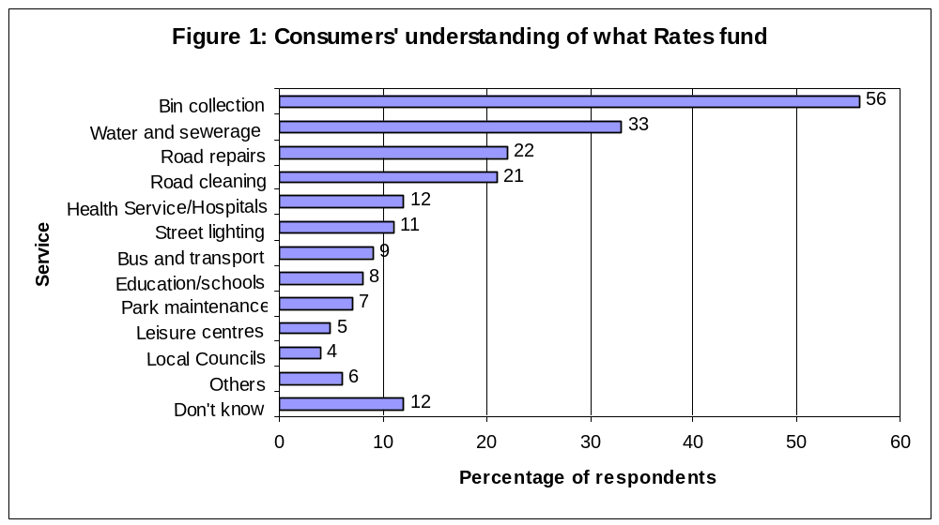
Evidence of this was also found on the Rates Collection Agency website that, until January 2005, stated water and sewerage services are provided for through rates. Consumers are confused further when even individual councils (for example Derry City and Antrim Borough Council) identify that rates pay for water and sewerage within existing publications.
- It is very difficult for all consultees, but particularly individual consumers as well as the wider community and voluntary sector, to grapple with the twin elements of a new impact assessment tool and new policy proposals. Many consultees have no previous knowledge, understanding or experience of the IIA process, which is being piloted in the Water Reform programme. Regrettably no attempt has been made to provide consultees with the capacity and training to understand the IIA process and how to use the tool ahead of a very important and complex consultation on Water Reform.
- There has been an unreasonably short period of time allowed to respond to the Water Reform IIA process. The 14-week consultation period for this consultation constitutes the defined minimum timescale of 12 weeks plus 2 weeks to allow for Christmas and the New Year period. The IIA process brings together a number of impact assessments for consideration within a limited consultation period. This is inadequate time to consider integrated impact assessments, which individually would have been afforded minimum consultation periods.

3. Response to Integrated Impact Assessment Overview
This section contains our response to questions raised in Part 1:Integrated Impact Assessment (IIA) Overview.

Overall, The Consumer Council is uneasy with many of the conclusions contained in the IIA overview. In addition, the rationale behind screening out some of the assessments is questioned. It is our view that there is a particular need for impact assessments in Health and Strategic Environment, but also for the Regional Development Strategy and Public Expenditure and Public Service.

Page 16: Legislative Obligations –Consultation Questions

1. Do you have any views on the conclusions reached by the Department to screen out from further assessment the implications of Water Reform in respect of:
- Human Rights
- The Regional Development Strategy
- State Aid
- Strategic Environmental Assessment

2. Is there any other evidence which you consider should have been taken into account in these assessments?

(a) Human Rights

The consultation document acknowledges that the proposals would place a Human Rights obligation on the Water Service ‘…to provide wholesome water supply and ensure appropriate treatment of waste water. The Consumer Council is unsure how this will be taken forward.

(b) The Regional Development Strategy

The Consumer Council acknowledges that funding for the Water Service should be secured on a sound financial basis to allow it to support balanced and sustainable development of services and infrastructure throughout Northern Ireland. However, in the absence of adequate resources to address the issue of affordability for those who are in danger of accumulating further debt and suffering hardship and poverty, the existing proposals do not provide for a secure funding stream for the Water Service. This is particularly pertinent against a backdrop of zero disconnection and cross-subsidisation of those who cannot afford to pay by other consumers.

Experience of water debt in England and Wales shows there are arrears of £893m (2002-2003). The result is that water companies have an annual non-recoverable debt of £164m. Alarmingly, the Office of Water Services’ (OFWAT) figures for outstanding revenue show a 17 per cent increase in debt levels between 1998/99 and 2003/04. Additionally debt write offs by water companies has increased by 50 per cent in four years. In the water industry, it is widely recognised that the growing level of customer debt is linked to issues of affordability. UK Water Industry research shows that over half of the debts that have to be written off come from people who earn below £10,000 per annum and a significant proportion are likely to be unemployed and/or in receipt of benefits. In England and Wales £527m of arrears to water companies (of a total of £893m consumer debt) is over 12 months old.

If the English and Welsh scenario were repeated here, this could mean an arrears figure of £29m in Northern Ireland and 169,926 (one in four) households at risk of water affordability, defined as spending less than 3 per cent of disposable household income on water charges. The 25 per cent discount proposed for low-income households in Northern Ireland is inadequate to address affordability issues for vulnerable and disadvantaged groups. The Consumer Council does not accept the argument that this discount should be accepted on the basis that it is better than the rest of the UK. The impact of a 75 per cent water charge on homes which cannot afford to pay has not been addressed within the IIA. It is not acceptable that the Government’s policy proposal of a 25 per cent discount is treated within the IIA as a method of mitigating the impact of the 75 per cent charge on vulnerable and disadvantaged households at risk of rising debt, poverty and hardship.

Professor Paddy Hilyard, who has examined this specific issue, commented on 4 February 2005 that the Government’s 25 per cent discount would have a limited impact on reducing the proportion of households defined as being at risk of experiencing water affordability or poverty problems.

Within a self-financing model those who can afford to pay for water and sewerage services are burdened with meeting the full costs of the system. Not only are the costs of the 25 per cent discount fully distributed among all other consumers, but they are also required to pay for the levels of mounting arrears and debts. In England and Wales the cost of the debt burden to other customers adds about £10 to each bill. Although the Vulnerable Consumer Groups Regulations are in place to address hardship relief it is clearly not working as take up levels for those eligible only amounts to 4 per cent. A Department for the Environment, Food and Rural Affairs (DEFRA) report in 2004 stated that in 2003/04 only 7,200 homes had received assistance under the scheme. It is essential that the Government urgently reassess its debt estimates on the basis of the information currently available, as it is our belief that they are underestimated.

It is The Consumer Council’s view that the Government’s policy proposals will not provide a secure financial basis for future funding without imposing additional increases on consumers and, subsequently, increasing levels of those who cannot afford to pay. As a result we do not agree that the Water Reform Programme is in harmony with the Regional Development Strategy, as it does not secure the financial basis required, and mistakenly places costs only on consumers. It ignores the principles of “polluter pays” as well the Government’s social responsibility to provide adequate protection for those who are vulnerable as they have done within their recent rating review relief proposals.

(c ) State Aid

There are no further comments on this issue.

(d) Strategic Environmental Assessment

The Consumer Council fully accepts the need to comply with the EU Water Framework Directive and other Directives. Further, we accept the assertion within the IIA that water and sewerage services’ investment plans are necessary not only to facilitate future development and to replace ageing infrastructure, but also to assist in achieving compliance with increasingly stringent EU directives.

However, it is our view that the existing proposals do not meet European legislation in premise or spirit. We do not accept that the proposed new direct water charges promote ‘… sustainability by introducing the concept that water is a costly resource that requires management’ for a number of reasons:

- Capital value does not reflect water usage levels particularly in properties with few or many inhabitants. Therefore the impacts for example on low occupancy homes in high property value areas will be adverse;
- A fixed average water and sewerage bill will not provide incentive to use water wisely. Consumers and experts alike have identified the link between what you use and what you pay as the real driver for efficiency (see Figure 2 below);
- Water leakage levels, currently at more than 30 per cent, will not be effectively addressed within these proposals. Metered systems are the most effective way to identify and address the issue of treated leaking water; and
- The water industry clearly recognises the maxim ‘you can’t manage it if you can’t measure it.’ The Organisation for Economic Co-operation and Development (OECD) has also stated that efficient and effective water pricing systems provide incentives for efficient water use and that the ‘metering of water consumption is a prerequisite for the application of efficient water pricing policies’. This is a view that The Consumer Council has also received from environmental legal advisors and the EU Commission itself.

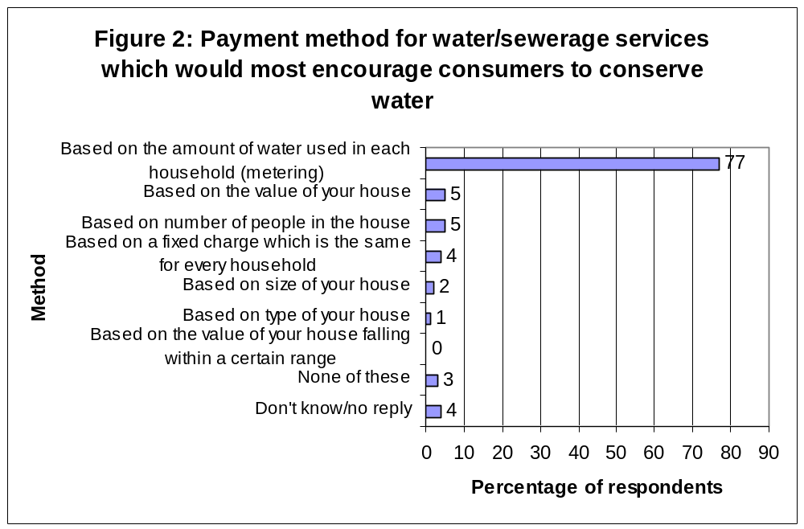

Over the past two years consumer views have remained constant in relation to metering being the most acceptable method of charging. In October 2004 61% agreed with the amount of water used (metering) being the method of charging, this compared with 63% who agreed in 2002. This is despite increasing public awareness of the costs and complexities surrounding metering implementation.

It is the Consumer Council’s view that the Government’s policy proposals are not consistent with the aims of the Environmental Directives. Further it is our view based on the evidence, research and opinions available that the proposals should be subjected to a full Strategic Environmental Assessment to confirm that the proposals are consistent with the EU Directive and thus avoid potential costly fines. Importantly, consumers should not have to suffer higher water charges because Crown Immunity is withdrawn.

The Environmental Impact Assessment is also required to help identify any future costs that would be needed to provide additional water if demand continues to rise. Equally, it would be able to help identify any savings that would accrue if demand for water reduced.

Page 18: Overarching Government Policy
Health Impact – Consultation Questions

- Do you have any views on the assessment of health impacts discussed in this section?

- Are there any other potential health impacts that you consider should have been addressed?

- Is there any other material evidence, which you consider should have been taken into account in this assessment of health impacts?

Water is a basic entitlement. It is unlike any other commodity; it is essential to life, health and hygiene. Worldwide, there is one death from water borne disease every ten seconds. The principle of ability to pay in the absence of full protection for those who cannot afford to pay has been discussed in the previous section. This issue has a particular and immediate relevance in relation to the impact of hardship and poverty on health and wellbeing.

The likely impact of further additions to the total household bill through direct water charges on those on lower incomes requires further analysis. This is supported by a report for the Department for Health, Social Services and Public Safety in 2001 which highlighted the likelihood of increases in poorer health and premature death as the burden of disadvantage increases.

When published in March 2002, the Northern Ireland Executive’s Investing for Health Strategy highlighted the huge gap between the those on high and low incomes in terms of health and wellbeing. The report powerfully and unequivocally stated:
“… that poverty is associated with ill- health must always have been obvious, except to those who did not care to look or wish to see.”

Key findings emerging from the Investing for Health Strategy were:

- Many factors affect mental and emotional health. Some affect people here to a greater extent than elsewhere, due to higher levels of poverty or political conflict;
- Life expectancy for the poorest men is seven years less than for the richest. The gap for women is four years;
- Those in the lowest occupational classes are more than twice as likely as those in the highest class to die from cancer;
- Among women, those in the lowest social class group (unskilled) are 60 per cent more likely to experience some form of neurotic disorder than those in the highest social class (professional);
- People who are unemployed are almost twice as likely to show signs of a possible mental health problem as those in employment.
- Poor people have less to spend on the physical determinants of health, such as good food, warm and comfortable housing;

The Consumer Council’s report “In Poor Health” also highlighted the difference between the wealthiest and the poorest in Northern Ireland. It demonstrated that those least well off were much more likely to suffer a series of stressors. Indeed, the poorest are more than three times more likely to have serious financial worries than the most wealthy as shown in Table 1 below.

Table 1: Significant stressors in lives (percentage)

 | Wealthiest | Poorest
Health Stress | 37.2 | 42.4
Job Stress | 9.4 | 19.5
Family Stress | 11.7 | 18.1
Major Financial worries | 1.9 | 6.2
Source: Dr D O’Reilly. In Poor Health, GCCNI, 2001

Based on overwhelming evidence of the health impacts of increased charges on those who are least well off (27 per cent of households are currently on housing benefit) The Consumer Council believes that the proposed policies will lead to an increase in levels of stress and anxiety in those who are unable to pay this new charge. This will likely include those who will try to pay their way, such as pensioners on fixed incomes and as a result to without other essentials that so many take for granted. They will be in the unenviable position of deciding whether to pay for their food, fuel or water.

The Council has studied with interest the work of the ‘Belfast Healthy Cities’ Health Impact Assessment for the Four Wards in the Ards Peninsula. This study should be considered in relation to the water reform proposals. It promotes the principles of fairness, equity and accessibility and has assessed the effects of the proposals on the health of the population in the Ards Peninsula. The results are discouraging of proceeding with a policy that does not address affordability fully and does not undertake a detailed Health Impact Assessment for the whole of Northern Ireland.

Theorists have identified how consumers consider food to be the flexible item of the household budget (Walker & Walker, 1997; Kempson, 1996; Nelson, Mayer & Manley, 1993; Leather, 1992; Lang et al, 1984). These studies illustrate how consumers consider it necessary to spend proportionately less on food in order to be able to afford other items within the total budget. It is likely that, as a consequence of these proposals, vulnerable consumers will reduce the amount of money spent on quality, nutritious food. There are also a range of other adverse impacts such as water borne and food borne diseases, malnutrition, depression and hypothermia.

Those affected by these proposals will also be subject to other forms of life-threatening hardships such as fuel poverty as identified in the Government’s NI Fuel Poverty Strategy. Northern Ireland has unprecedented levels of fuel poverty affecting an estimated 203,000 – or one in three - households.

The Consumer Council welcomes the decision to introduce a no-disconnection policy for non-payment of water charges given the essential status of water and sewage disposal for health and hygiene purposes. However, those paying for water may make choices particularly in relation to heating or eating, due to the associated loss of income, which would be detrimental to their health. This impact must be assessed.

It is our strong recommendation that the health impacts of these proposals need to be screened into the IIA. Reference should be made to the Department of Health, Social Services and Public Safety’s Investing for Health Strategy, and advice sought from the Institute of Public Health in Ireland who are leading in Health Impact Assessments.

Page 23: Overarching Government Policy
New TSN – Consultation Questions

- Do you have any comments on the new TSN analysis provided by the Department?
- Do you have any comments on the conclusions reached by the Department in respect of the compliance of Water Reform with New TSN?
- Is there any other evidence which you consider the Department should take into account?

Critically, the Government has not assessed the impact of its joint and holistic proposed charging method of a standing charge/capital value proposal as a whole. This must be undertaken.

All emerging policy proposals must comply with the Government’s basic policy objectives. The current water reform proposals do not support the objectives of New Targeting Social Need (new TSN) or their current consultations in relation to an Anti-Poverty Strategy here. These proposals will reduce the impact of any progress on tackling poverty levels in Northern Ireland under the Government’s new TSN strategy. Professor Paddy Hilyard commented that the Government’s 25 per cent discount would have a limited impact on reducing the proportion of households defined as experiencing difficulties with water affordability. Nowhere have the proposals examined the issue of affordability from a ‘bottom-up’ approach to ascertain the scale of the issue facing the most vulnerable in society.

The scale of the problem in Northern Ireland is well documented with:

- 185,000 households in poverty (502,200 people including 148,900 children);
- Household incomes are much lower (18% lower gross incomes and 15% lower disposable incomes) in Northern Ireland than in UK as a whole;
- The average individual’s debt in Northern Ireland, excluding mortgages, is £2,300. Consumers with mortgages tend to have higher debts with £5,700 excluding their mortgage and £47,500 including their mortgage.
- 20 per cent of consumers use credit to pay regular household bills;
- One in five households in Northern Ireland are living on less than £200 per week while 50 per cent of households have a weekly income of less than £300 per week;
- Northern Ireland also has the highest level of income support claimants and a greater reliance on benefits with, on average, 19 per cent of household income coming from benefits compared with 12 per cent in the UK as a whole;
- In Northern Ireland, 174,000 households are in receipt of Housing Benefit – a means tested benefit.
- One in three households in Northern Ireland is classified as fuel poor.

Water is unlike any other commodity or service which we have to pay for. It is essential to life and public health and therefore those who genuinely cannot afford to pay should not be further burdened by the proposed water charge. The Consumer Council’s research shows the range of groups which the public identified as requiring protection as shown in Figure 3 below.

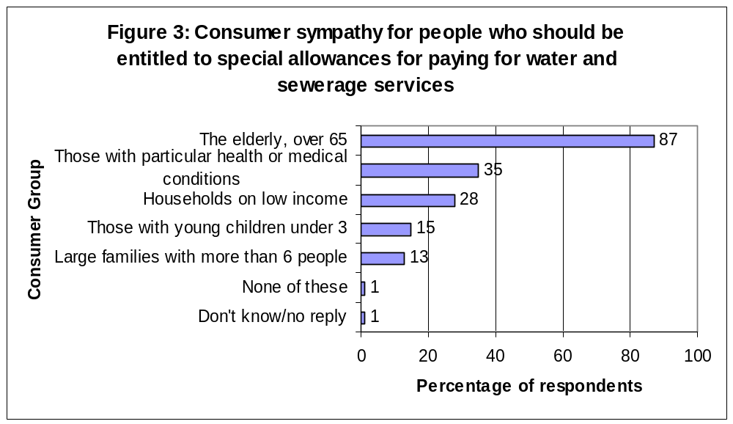

The levels of protection proposed in the recent Rating Review, which are also based on discrete capital value, are much greater than those within the water reform proposals – and yet the households in need are the same. The Government has a social responsibility to ensure that every consumer is able to afford an adequate supply whether that consumer is a pensioner living alone, on low-income or someone in particular personal circumstances requiring support.

Water Arrears and Debt

Points raised previously in relation to water arrears and debt and their impact on those who cannot afford to pay relate to points in this section also. It is calculated that 1 in 5 homes in England and Wales are in arrears and debt to their water company is estimated at £893m of which £527m is more than 12 months old. It is estimated that water companies account for one quarter of all County Court Judgements. If these figures were pro rata applied to Northern Ireland then it would equate to approximately £29m arrears. It would also impose an additional £58 burden on paying households. This is a conservative estimate, as it must be remembered that this debt will be accrued against lower incomes and higher benefits dependency.

Consumers are not in a position to be able to assess if they are going to pay a fair price that is value for money and provides protection for those who cannot pay. The Government has estimated the charge to be in the region of £315 - £415. This range represents a 32 per cent differential. A full understanding and response to the fairness of the charge to reflect the needs of the investment programme requires the publication and studying of the Strategic Financial Review.

Water Affordability

It is imperative that any new system does not cause water affordability and debt problems; therefore, adequate protection must be built in from the outset. Using the definition of water affordability equating to spending less than three per cent of income on water bills then the average water charge of £340 for Northern Ireland domestic consumers would equate to up to 169,926 households i.e. one in four are at risk of problems with water affordability (see Tables 2 and 3). It is worth noting that these figures are potentially underestimated as they are gross income based rather than disposable income, which is the contemporary definition adopted by DEFRA

An average water charge of £340 would mean that households would need a disposable household income of £11,333 to avoid water affordability problems. (See Tables 2 and 3 below). This is approximately £1,800 - £2,500 higher than in England, Scotland and Wales where household incomes would need to be between £8,800 and £9,533 to provide water affordability. Worryingly, the discounted 2008 average water charge of £255 is 4.38 per cent of the current level of single pensioner’s pension credit.

Table 2: Estimated number of households at risk of water affordability problems based on full charge

If the full price were  (£) | Minimum income (to be water affordable) (£) | % of NI households earning less than this minimum income | Estimated number of NI households at risk  (base = 669,000)
150 | 5,000 | 1.9 | 13,000
200 | 6666 | 7 | 47,000
250 | 8333 | 12.8 | 86,000
300 | 10000 | 18.6 | 124,000
315 | 10500 | 20.6 | 138,000
365 | 12167 | 30.2 | 202,000
415 | 13833 | 39.8 | 266,000

Note: Above Table is using gross household income.

Table 3: Estimated number of households at risk of water affordability problems based on 25 per cent discounted charge

Discounted water charge including 25% discount (If the full charge were) | Minimum income to be water affordable (£) | % of NI households | Estimated number of NI households  (base = 669,000)
113 (150) | 3,750 | 1.4 | 9,000
236 (315) | 7,875 | 11.1 | 74,000
255 (340) | 8,500 | 13.3 | 88,643
274 (365) | 9,125 | 15.4 | 103,000
311 (415) | 10,375 | 19.6 | 131,000
Note1: Table 3 makes the critical assumption that all households receive the discount.
Note2: Above Table is using gross household income.

Government Protection for Vulnerable Groups

It is our firm belief, and overwhelmingly that of consumers, that the Government, not other consumers, should fund the protection of vulnerable and disadvantaged householders through its social policy responsibility as shown in Figure 4 below from our consumer research.

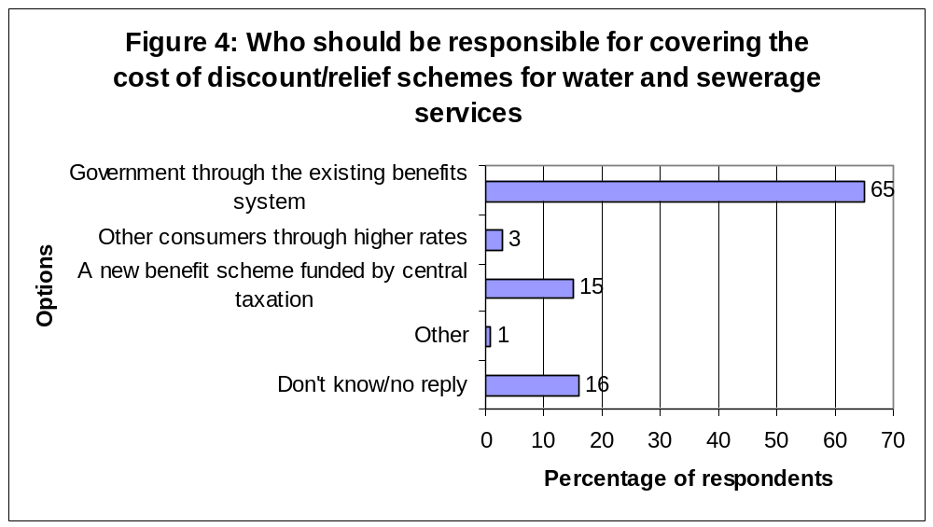

How Do We Meet the Cost?

Obviously, everything has to be paid for. Early calculations carried out by The Consumer Council suggested that £50-60m would be required to fund full protection of vulnerable consumers, assuming they all paid the average price. These have been updated as a result of studying the Government published figures, which estimate that it would cost £10m to fund a 25 per cent discount. Therefore, our revised figures estimate that it would cost approximately £40million for a 100 per cent discount.

There are a number of potential streams which should be rigorously explored here and with Treasury for ensuring that the issue of affordability is fully dealt with ahead of the introduction of water charges here.

For example, the Government has confirmed that Northern Ireland has been receiving a £50m contribution towards water and sewerage services or ‘green dowry’ allocation since the early 1990s through the Barnett formula. This money has been identified for water and sewerage service developments but has been consistently diverted into other public services. From now on this money should be spent on freeing up £50m to address the greatest issue pertaining to these proposals – protecting those who cannot afford to pay within a zero-disconnection, self-financing arrangement.

Alternatively, a proportion of the money saved from the existing costs of the Water Service of over £300m would provide sufficient protection and still allow in excess of £260m to be made available to other essential public services.

We note the issue of fuel poverty in UK has been recognised by Government and that approximately £2.4bn has been allocated to fuel poverty initiatives from central public funds. Given that water is essential to life, we are concerned that Government is not attributing priorities that reflect this.

Implications of a self-financing system

In the proposed self-financing system, households that choose not to pay or cannot afford to pay will be subsidised by the remaining paying consumers. This has implications for other householders and ultimately, the incidence of hardship, debt and potentially, water affordability problems. For example, as shown in Table 4 below, if 10 per cent fail to pay their average water charge of £340 it means that 90 per cent will see a bill of £340 increase to £378 as a result. This trend is unsustainable and presents real affordability problems for Northern Ireland households where one in four households have an income of less than £200 per week.
Table 4: The effect of non-payment on paying consumers’ water bills

% of households paying £340 water charge | Cost (£) to paying households
50 | 680
60 | 567
70 | 486
80 | 425
90 | 378
100 | 340
Note: This calculation makes the critical assumption that all households will be billed at the average charge of £340

The effect of using capital house value is not ‘ fair and equitable’. If paying for water is deemed to be a charge rather than a tax then it is not appropriate to use house values, which provide no reflection of usage or ability to pay within that household. This causes a high degree of cross subsidy within the system between consumers, which again reduces confidence in the system of charging proposed as shown in Figure 5.
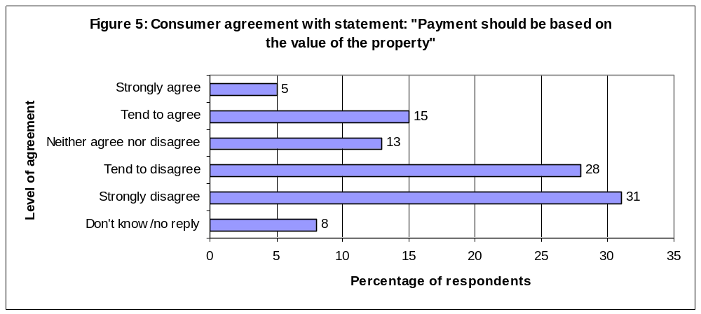

Universal Metering To Provide Protection

While the Consumer Council recognises that more debate is needed on metering, we believe that making a water allowance available in a universal metering system offers an effective instrument for protecting those who cannot afford to pay or those in exceptional need circumstances.

We therefore believe that consumers who need protection should receive a specified free allowance of water in a metered system, based on vulnerability, which can be adjusted depending on the particular numbers and circumstances of individual consumers and households. This will provide protection for those living alone as well as larger, low-income families as the water allowance would be based on each person in the household. Similar protection systems are currently used in other countries such as Belgium. Under the present system, there is already a built-in water allowance system here through the allowances given to farm households. A free water allowance could also be used to deliver the Government’s proposed “hardship” scheme. Otherwise, the impact of these proposals will also be to remove the domestic allowances from all farms causing further rural hardship and impacting on the Government’s targeting social need objectives.

The Consumer Council supports the IIA’s proposal that a zero disconnection policy will be put in place due to water’s essential life giving and maintaining nature. To avoid any disconnection problems occurring in the first place it is essential that an adequate protection system be put in place for those who cannot afford to pay. It is equally important that the system does not perpetuate water arrears, which will then be paid for by other consumers.

It is our view that the proposals do not support the Government’s new Targeting Social Need objectives. Further, the proposed discounts do not mitigate against impacts on low-income households. Rather, the inadequacy of the discount proposals add to the impacts in terms of hardship, debt, poverty and financial exclusion. Affordability issues can be addressed ahead of the introduction of water charges and should be borne by the Government and not other consumers. The self-financing system in itself is impacting on those who currently can afford to pay and may have to pick up further costs which they in turn cannot afford.

Page 32: Overarching Government Policy
Rural Proofing – Consultation Questions

- Do you have any views on the analysis of rural impacts discussed in this section?

- Are there any rural impacts that you consider should have been addressed?

- Is there any other material evidence which you consider should have been taken into account in this assessment of rural impacts?

The principles of fairness, affordability and sustainability expressed throughout this respond equally apply to rural communities. However there are also further considerations to be assed in terms of the rural community.

The proposed changes comes at a time when the farming industry is also facing increased water related costs in relation to the implementation of the Nitrates and other EU Directives. They are also likely to be affected by the changes to the domestic rating system. This will have a similar cumulative impact on farm incomes.

The average net farm income in Northern Ireland is £8,500. This is significantly below the average household income for Northern Ireland. This lower income, coupled with the fact that farm houses are often larger properties than urban domestic households has implications for the affordability of water and fairness of the proposed charging regime for farming families. This is because farmers, as a consequence of the potentially higher capital value of their property, may face high water bills that are unaffordable given their potential to be asset-rich and income-poor.

Furthermore, farming families are already metered for their business use but, their annual domestic allowance of 200m³ will be phased out over the three-year period between 2006/7 and 2008/9. It is therefore important that farming families’ ability to pay is taken into account – something that we have already stated these proposals do not achieve. Furthermore, the Ulster Farmers’ Union has publicly supported The Consumer Council’s proposals in our document “Water – A Clear Way Forward” published in November 2004.

Page 33: Overarching Government Policy
Community Safety – Consultation Questions

- Do you have any views on the conclusion reached by the Department that there is no need to perform a Community Safety Assessment in respect of Water Reform?

The Consumer Council agrees that there is no need to perform a Community Safety Assessment in respect of Water Reform.

Page 34: Overarching Government Policy
Public Expenditure and Public Service – Consultation Questions

- Do you agree with the Department’s view that a separate economic appraisal of Water Reform is not required?

The Consumer Council believes that a separate Economic Appraisal is necessary. It is our belief that an economic appraisal, particularly of the charging options, showing value for money and benefits and disadvantages has been long overdue.

We also believe that there has been no economic appraisal completed of the business model overall. We note that in 2003 the Water Reform Unit consultation document stated the decision to transfer to a GoCo was ‘taken as a first step towards privatisation’. The Consumer Council would request access to the option analysis and evidence to support the establishment of a GoCo as the best possible model for Northern Ireland.

We are aware that a Strategic Financial Review is being undertaken by DRD. This will not be complete until the end of March. We believe this should be published and discussed further, once available, to incorporate any issues arising from the Review.

Page 35: Overarching Government Policy
Victims – Consultation Questions

- Do you agree with the Department’s view that Water Reform will not have particular impacts on victims?

We have no comments to add to this section

4. Response to Equality Impact Assessment

The Department would particularly welcome feedback on the following:

- On the assessment performed;

- On the draft conclusions; and

- Any other relevant qualitative or quantative information which you consider should have been taken into account in performing this analysis.

It is our view that the Equality Impact Assessment (EqIA) has a number of issues which need to be addressed ahead of the policy finalisation and draft legislation. The draft conclusions to the EqIA are incomplete and therefore do not fully assess critical impacts:

- The EqIA does not assess the actual method of charging to be introduced, namely the hybrid of a capital value charge with a fixed charge. This is a major defect and renders the EqIA incomplete;

- The metering issue is not addressed satisfactorily. There is no information on the form of metering which is being subjected to assessment. It should be noted that different methods of introducing metering would render differing impacts and implications.

- Any form of metering being proposed as the long-term policy and strategy decision requires an equality impact assessment. A position on metering is required and the Water Reform process must allow adequate time and opportunity to discuss and establish an appropriate metering policy. For example any emerging decisions in procuring billing systems, must ensure that it does not render any metering option unviable;

- The EqIA has failed to assess the impact on those who are subject to hardship, poverty and debt as a result of the 25 per cent discount policy proposal and the potential incidence of water affordability problems in line with internationally agreed definitions;

- Mitigation measures are wholly inadequate as discussed previously;

- The EqIA screens out impact on disability groups and major parts of the reform programme that have not been discussed i.e. establishment of GoCo;

Assessing Method of Charging

The EqIA reviews the information in the Equality Technical Appraisal which was carried out as part of the analysis to inform the draft Equality Impact Assessment. This information is available on the Department of Regional Development website. This appraisal contained further consideration and analysis of some of the options for domestic charging. The analysis showed that of all the charging options considered metering would result in the least differential impact.

Those options considered in a number of different analysis were:

- June 2003: Property based charge, Flat Charge and Metering. It was concluded that metering would result in the smallest equality impact.
- March 2004: Capital value based charge and charge based on property size. It concluded that a charge based on property size would have lesser equality effects.
- August 2004: Discrete capital value based charge only.

The EqIA does not consider the specific form of metering and range of tariffs that are currently available. This is a further gap within the EqIA and requires further immediate analysis and conclusion.
Regressivity of Fixed Charge Element

To introduce the fixed element of the charge as a mitigation measure by stating ‘..It has the effect of reducing the overall property-related element’ fails to consider the regressive nature of the fixed charge.

Table 5 below clearly shows that the fixed charge forms a higher proportion of lower bills thus impacting aversely on many equality groups. Indeed the fixed proportion of the charge is five times greater for the lowest than for the highest bills. For example, at the minimum cap, almost three-quarters (73 per cent) of the bill is fixed compared to 15 per cent of the maximum cap’s bill being fixed.

Table 5: Regressivity of the Fixed Charge

Total charge | Fixed | Variable | Fixed as % of total | Remarks
£150 | £110 | £40 | 73.3 | Lowest charge
£315 | £110 | £205 | 34.9
£340 | £110 | £230 | 32.3 | Average Charge
£415 | £110 | £305 | 26.5
£750 | £110 | £640 | 14.7 | Capped charge

The Consumer Council does not support the use of fixed or standing charges as it has regressive impact on lower income households. The electricity and gas industries in Northern Ireland have largely moved away from fixed or standing charges for these reasons, yet they also are infrastructure intensive industries. Any charging regime should have fixed costs built into the overall unit price/cost.

Additionally we fail to see evidence from the three phases of the technical appraisal to support the discrete capital value charging regime. If the more precise ward-level analysis was available in 2004 the question can be posed as to why the analysis was not extended to the other methods of charging, such as metering. This particularly when metering had been identified as having a lesser impact than a property value based charge system when compared in June 2003. This is equally important in light of the research from the Joseph Rowntree Foundation. It showed that metering with protection (water allowances) was a fairer and more progressive system of charging than any charge based on rateable value and had least impact on lower income households.

In June 2003, the Equality Technical Appraisal admitted that a mixture of fixed and variable charges had not been assessed and that:

‘if this becomes a viable option, the equality effects will be the appropriate mix’.
This assessment is unavailable and therefore equality effects and impacts cannot be measured.

Addressing Metering Issue

The EqIA and Proposals documents do not clarify the form of metering that may be introduced within the provisions made available. Nor are there details provided on the tariffs or allowances that might be provided. The definition of the form of metering to be employed within an impact assessment is important. For example, a voluntary system would have significant equality impacts since more wealthy households would change to meters under an optional system, similar to the one used in England and Wales. This would increase bills on lower income consumers. Evidence from the Joseph Rowntree Foundation reinforces this by stating:

‘voluntary metering is the most expensive option of all,’ and that ‘additional administrative costs of metering and billing are not borne by those being metered, but shared among all consumers, which is effectively a subsidy of the metered by the non-metered’.

Under a metered system with in-built water allowances the vulnerable can be protected and the system can be progressive in that there is a correlation between income and water use. This is discussed further in ‘Water – A Clear Way Forward’. A recent report by the Joseph Rowntree Foundation shows metering as much fairer on low-income consumers than rateable value based systems. The research concludes that ‘metering could be financially beneficial for most low-income households, provided that care was taken with the design of tariff structures.’

Findings considered eleven tariffs options and showed that:

- Low income households are not necessarily worse off with meters. Of the eleven tariffs examined in the report all of them were less regressive and actually left households better off.
- Allowances could be made for essential reasons, such as medical issues, to reduce any extra charges under a metering regime.
- Detailed tariff design can provide effective protection for low-income groups in a metered system.

It is our belief that focused discussion and investigation is needed on metering options at home and further afield to identify the best way forward to provide fairness for all and adequate government funded protection for the vulnerable.

Comments on the Draft Conclusions to the EQIA

Conclusions on the equality effects within the EqIA are, in our opinion, made without adequate supporting data. It is also unclear if full consultation was carried out with affected groups and their representatives, such as disabled people. Other comments are:

- Religious Belief. It is agreed that the perceived Protestant population will suffer disproportionately as they generally will own homes in areas where house prices are highest. However, the EqIA has not considered if the impact of water affordability would have a differential impact in relation to religious belief.

- Political Opinion. As with the point above Nationalists living on lower average incomes will suffer with the regressive fixed charge and in relation to water poverty.

- Given the link between disability and low, fixed income it is also probable that people with disabilities will be more likely to be subject to hardship, debt and poverty, suffer from the regressive impact of a fixed charge.

- The impact of water affordability could have been a differential impact across various equality groups. This may be different from the impacts identified in the EqIA which are based on an analysis of who will pay more in actual monetary terms rather than who will be in greater poverty or pay the largest proportion of income.

Response to Mitigation Measures

We believe the alternative/mitigation measures are not acceptable;

- The standing charge may reduce the overall property related element of the domestic charge but it fails to consider the regressive nature of the fixed element on lower income households;

- The cap benefits the highest value homes and effectively under the proposed system forces those in lower value homes to pay more. This appears particularly unfair when the gap between rich and poor is widening. There should be greater government intervention in the form of social policy. No such caps exist for electricity or gas charges in Northern Ireland and if consumers should be paying based on their ‘ability to pay’ and are not cross subsidising other groups then the cap should be withdrawn. A system that reflects usage would therefore remove cross subsidy of this nature;

- Protection for low-income groups is wholly inadequate. A 25 per cent discount is still going to leave 75 per cent new charge to pay. The proposed system is likely to significantly reduce the effectiveness of the Government’s new TSN strategy as discussed previously;

- There has been no comprehensive study into domestic metering. If phase 1 of the equality technical appraisal in June 2003 demonstrated that metering would result in the smallest impact it is disappointing that no further research or analysis is available now almost two years on. The Department for Regional Development is currently issuing tender documents for a billing system in the absence of decisions being made on the long-term charging policy. It is imperative that any decisions made now do not rule out a number of realistic options for long-term metering, which could lead to increased future costs. These would again be borne by consumers through higher bills;

- The phasing-in of charges by one third each year still fails to address the impact on Section 75 Groups of this completely new direct charge. Low-income families will not be increasing their incomes on an annual basis at the same rate as incomes and benefits, particularly as this will be an additional charge to the current rates bill;

- The Water Efficiency programme of £43m in the Water Service cannot be classified as a mitigating measure. These efficiencies are already factored into overall costs and we will still see real hardship with low income and vulnerable groups. In the early years of the Reform Programme, water and sewerage bills will rise in line with the investment profile;

- The assessment does not take into account the impact on the total household bill including increasing rates bills (under a new valuation system) alongside new water bills.

Screening out of major parts of the reform programme

We are concerned that certain aspects of the reform programme have been screened out. These issues may have impacts on vulnerable groups i.e. the decision to establish the GoCo.

We would wish to know why no EqIA of the non-domestic sector has been completed.

5. Response to Partial Regulatory Impact Assessment

- Do you have any general comments on the overall approach that was taken in completing this Regulatory Impact Assessment (RIA)?

- Do you consider that there are any other issues which need to be either assessed or taken into account in the development of the non-domestic charging arrangements?

- What are your views on the identification and assessment of costs?

- What impact do you think these additional costs will have on businesses and other voluntary and community organisations?

- What sectors or types of businesses/organisations do you think might be particularly vulnerable to the introduction of comprehensive charges?
- What are your views on the identification and assessment of benefits?

- Do you agree that the benefits outlined justify the changes in the charging regime covered in our proposals?

- Do you agree that the proposals represent a fair and equitable means of charging non-domestic properties for the costs that they impose on the water and sewerage system?

The Consumer Council’s response has focused on the impact of water reform proposals on domestic consumers. However, we recognise that water reform will also have a significant impact on the local business and industrial community as they grapple with high business costs in other areas and the impact that will result from the removal of industrial de-rating. It is important that the views of the business community, represented by the Federation of Small Businesses, Confederation of British Industry, and Institute of Directors among others are taken into account in relation to the overall impact on businesses here.

The Consumer Council is pleased that the IIA has considered the wider cost environment in which businesses operate. The fact that some key operating costs are already higher than elsewhere (e.g. energy, transport and insurance) seems to have been considered for non-domestic users. This fact is acknowledged in the RIA where it states

‘…it is important to be mindful that any increase in water costs will not occur in isolation’.

However it is a major omission that the same issues have not been acknowledged or considered in relation to domestic users. The IIA does not acknowledge or confirm rises in rates, higher energy costs and insurance for households amongst other essential items. Northern Ireland households spend 6 per cent more of gross household income on everyday essential items compared with households in the UK as a whole, appoint which will be discussed further in Section 6 of this response.

6. The Consumer Council’s Additional Impact Assessments

Throughout the development of the Water Reform proposals The Consumer Council has been addressing many public meetings, undertaking research, engaging with social partners, meeting with political, trade union and community representatives, consulting with the Government, briefing and responding to the media as well as meeting with members of the business and farming community.

Water reform is the biggest and most complex consumer issue affecting every single household and business in Northern Ireland. The Consumer Council is struck by the depth and widespread sharing of feelings of concern, distrust, fear and cynicism here. The Consumer Council also feels that the Government has not succeeded in providing an open and informed debate relating to the drivers for the reform as well as the options and proposals. In order to fill this void and provide leadership on this important issue, The Consumer Council has sought to inform the debate and stimulate discussion through its ongoing consumer research and production of information and proposals papers.

We are also aware of the lack of confidence or support for the current proposals; this includes individual householders, businesses, the farming community and a wide range of organisations. That is not just because it is a new charge; rather it is because people are not convinced that the proposals will provide a system that is both fair and affordable. There is a clear consensus that the existing proposals must be modified to reflect the concerns of both those who can afford to pay, and those who cannot.

The Consumer Council has responded to the Government’s request to bring forward further evidence of impacts and views on their policy proposals to aid their further development and draft legislation for the introduction of Water Reforms.

What the Consumer Thinks

Our comments and analysis are influenced and shaped by the feedback and independent consumer analysis conducted first in 2002 and updated in 2004. The latest research is contained in Annex A, but the headline findings are:

- Just under three quarters (72 per cent) agreed that those who can least afford water should pay less;

- It was a strongly held view by most (65 per cent) that the Government should be responsible for covering the cost of discount or relief schemes for water and sewerage through the existing benefits system;

- Almost two thirds (63 per cent) agreed that those who use a public service more should have to pay more for it;

- More than three in five (61 per cent) respondents stated that water and sewerage service charges should be calculated on the amount of water used in each household (metering), as opposed to being based on the number in each household (12 per cent), or indeed the value of the property (nine per cent);

- More than three quarters (77 per cent) agreed that those who use most water should pay the most; only 13 per cent of respondents disagreed with this statement;

- Some three in five (59 per cent) disagreed that payment should be based on the value of the property; one in five (20 per cent) agreed with this;

- Almost four in five (77 per cent) stated a payment method based on the amount of water used in each household (metering) would best achieve conservation. A charge based on the value of the house or a charge based on the number of people in the household was supported by only five per cent.

Our own separate website-based questionnaire also demonstrated that more than 60 per cent of respondents preferred metering as the best way to pay for water charges. Our on-line opinion poll also registered support among two-thirds (66 per cent) of voters by 28 February 2005 for our alternative proposals as published in our water analysis report ‘Water – A Clear Way Forward’. We also requested feedback on our alternative proposals; a variety of organisations, city and district councils and individual respondents have consistently supported our approach.

Differentials in Household Expenditure and Income

The Government has regularly referred to the difference between the amount that households in Northern Ireland pay in rates and water charges (£509 in 2004/05) compared with England and Wales (£1216 in 2004/05) and also Scotland (£1158 in 2004/05). The Consumer Council believes that water charges should be calculated on what monies are needed to be collected to fund the needs of water and sewerage services and infrastructure. Northern Ireland’s needs, circumstances and costs must be the derivative of any charges and rates rather than unfair and incomplete comparisons with levels of revenue collected in the rest of the United Kingdom.

Comparisons of the amount of household taxation (e.g. rates/council tax and water bills) paid in the rest of the United Kingdom and Northern Ireland do not take into account the wider context of household expenditure. Part 3 of the IIA, the Partial Regulatory Impact Assessment, gives appropriate recognition of businesses’ high energy costs and insurance costs. However, the same understanding is not given to householders’ increased regional and domestic rates, high energy costs and higher household expenditure.

Total Household Bill

The consumer in Northern Ireland is facing the introduction of a new direct water charge alongside rising rates bills with no recognition of the amount already contributed to indirectly in rates at present for water.

To calculate the total household bill and better understand its impact on consumers, we sampled a random variety of households around Northern Ireland. Our analysis, as shown in Table 6 below, identifies alarming increases in the amount being paid out by households here and yet it does not even take into account the recently announced rises in the regional rate for the next three years, which will be nine per cent, nine per cent and then six per cent. It also does not take account of any increase in the District Rate, which at present constitutes 45 per cent of the total rates bill and is likely to increase over the next few years with the obligations being placed on local councils in relation to waste management. A snapshot of the effect of the new rates and new separate water charge in 2008-2009 is below:

Table 6: Effect of ‘new’ water and rates bills in 2008-2009

Examples | House Value | Current  Rates  Bill  (04-05) | New Rates  Bill | New Water Charge  (Minimum) | New  Total | Increase  On Current Rates Bill
Terrace  E Belfast | £65,000 | 292 | 325 | 235 | 550 | +£258  (88%)
Semi,  Londonderry | £86,000 | 610 | 430 | 275 | 705 | +£95  (15%)
Detached,  Ballymena | £92,500 | 560 | 460 | 275 | 735 | +£175  (31%)
Semi,  Maghera | £105,000 | 540 | 525 | 275 | 800 | +£260  (48%)
Semi,  South Belfast | £145,000 | 587 | 725 | 315 | 1,040 | +£453  (77%)
Detached,  South Belfast | £220,000 | 886 | 1,100 | 515 | 1,615 | +£729  (82%)
Terrace,  Holywood | £340,000 | 675 | 1,700 | 750 | 2,450 | +£1,775  (263%)
Detached,  Strabane | £350,000 | 1,098 | 1,750 | 750 | 2,500 | +£1,402  (127%)

Sources: ‘Reform of the Domestic Rating System’ DRD Policy Paper 2004 and DRD Press Release regarding introduction of new household water charges, 13 September 2004

Comparison of Costs of Everyday Essentials

Although a straightforward comparison of household taxation may demonstrate that Northern Ireland pays approximately £700 less per year per household, consumers have higher household expenditure costs than the rest of the United Kingdom. As Tables 7 and 8 show Government statistics, in the Expenditure and Food Survey 2002-03, show that:

- Expenditure on household items forms 12 per cent more of gross household income than UK average;

- Northern Ireland households spend 6 per cent more of their gross income (46.4 per cent) on essential goods and services than the UK average (40.7 per cent of gross household income). This includes housing, rates and water costs.

Table 7 shows that if water charges were added (an average of £340 water charge, equating to £6.54 per week) it would increase Northern Ireland weekly expenditure to £389.34. This would mean that household expenditure would equate to 86.9 per cent of gross household income, widening the gap with the rest of the United Kingdom.

Table 7: Total Weekly Household Expenditure – Essentials and Non-essentials
£ Expenditure on Item | England | Wales | Scotland | UK | NI | NI Differential
Food /non-alcoholic drinks | 42.30 | 39.60 | 42.20 | 42.20 | 46.20 | +4.00
Alcoholic drinks/tobacco/narcotics | 11.00 | 11.20 | 13.40 | 11.30 | 13.50 | +2.20
Clothing/footwear | 22.50 | 17.80 | 23.10 | 22.50 | 30.20 | +7.70
Housing/fuel/power | 37.30 | 31.90 | 32.40 | 36.50 | 30.30 | -6.20
Household goods/services | 30.50 | 26.20 | 26.60 | 30.00 | 31.30 | +1.30
Health | 5.00 | 2.90 | 3.60 | 4.70 | 2.80 | -1.90
Transport | 60.00 | 45.00 | 50.40 | 58.20 | 52.60 | -5.60
Communication | 10.60 | 8.50 | 9.70 | 10.40 | 10.20 | -0.20
Recreation/culture | 56.00 | 51.20 | 49.40 | 55.00 | 48.00 | -7.00
Education | 5.70 | 2.90 | 4.20 | 5.40 | 4.10 | -1.30
Restaurants/hotels | 34.70 | 29.10 | 31.10 | 34.10 | 35.00 | +0.90
Misc. goods/services | 32.70 | 25.30 | 27.30 | 31.80 | 31.40 | -0.40
All expenditure groups | 348.40 | 291.50 | 313.30 | 342.10 | 335.80 | -6.50
Other expenditure items * | 60.00 | 44.20 | 51.80 | 58.20 | 47.00 | -11.20
Total expenditure | 408.40 | 335.70 | 365.10 | 400.30 | 382.80 | -17.70
Household income (£) | 561.00 | 451.00 | 490.00 | 546.00 | 448.00 | - 98.00
Expenditure as % of gross income | 72.8 | 74.4 | 74.5 | 73.3 | 85.4% | +12.1%

Source Data: The National Statistics 2003 Edition UK - Family Spending: A Report on the 2002-2003 Expenditure and Food.

Table 8 shows that if water charges were added (£340 average water charge equating to £6.54 per week) it would increase Northern Ireland ‘essential’ weekly expenditure to £214.34. This would mean that household expenditure would equate to 47.8 per cent of gross household income, again widening the gap with the rest of the United Kingdom.

Table 8: Weekly Household Expenditure – Essentials Only

£ Expenditure on Essential Items | England | Wales | Scotland | UK | NI | NI  Differential
Food /non-alcoholic drinks | 42.30 | 39.60 | 42.20 | 42.20 | 46.20 | 4.00
Clothing/footwear | 22.50 | 17.80 | 23.10 | 22.50 | 30.20 | 7.70
Housing/fuel/power | 37.30 | 31.90 | 32.40 | 36.50 | 30.30 | -6.20
Health | 5.00 | 2.90 | 3.60 | 4.70 | 2.80 | -1.9
Transport | 60.00 | 45.00 | 50.40 | 58.20 | 52.60 | -5.60
Misc. goods/services inc toilet paper, toiletries, soap, household and vehicle insurance and bank charges | 15.30 | 12.50 | 12.80 | 15.00 | 16.50 | 1.50
All expenditure groups | 182.40 | 149.70 | 164.50 | 179.10 | 178.60 | -0.50
Other expenditure items inc mortgage interest payments, water and council tax, licences, fines and transfers and interest on credit cards* | 45.60 | 31.00 | 38.60 | 43.10 | 29.20 | -13.9
Total essential expenditure | 228.00 | 180.70 | 203.10 | 222.20 | 207.80 | -14.90

Household income (£) | 561.00 | 451.00 | 490.00 | 546.00 | 448.00 | - 98.00
Expenditure as % of gross income | 40.6% | 40.1% | 41.5% | 40.7% | 46.4% | +6.3%

Source Data: The National Statistics 2003 Edition UK - Family Spending: A Report on the 2002-2003 Expenditure and Food.

Comparison of Household Income

Average gross household income in Northern Ireland is 18 per cent / £98 per week less (£5,096 pa) compared with the UK national average; according to the Government’s Expenditure and Food Survey and illustrated in Table 9 below. Similarly, average disposable income in Northern Ireland is 15 per cent/£68 per week less (3,536 pa).

Table 9: Comparison of household income Northern Ireland v GB 01-02/02-03

Region | Average Gross Weekly Household Income (£) | Average Disposable weekly Household Income (£)
England | 561 | 459
Wales | 451 | 381
Scotland | 490 | 404
Northern Ireland | 448 | 380
UK Average | 546 | 448

Source: The National Statistics 2003 Edition UK - Family Spending: A Report on the 2002-2003 Expenditure and Food Survey. Essential items relate to essential goods and services, which are not optional for households.

In terms of income, Table 10 below shows that 20 per cent of Northern Ireland households earn less than £200 per week (annual salary of less than £10,400) while 50 per cent earn less than £300 per week (annual salary of less than £15,600) as shown in the table below.

Table 10: Proportion of Northern Ireland Households by Income Bracket
2002-2003 | Annual Salary Equivalence (£) | Households in each weekly income group (per cent) | Number of households in each weekly income group
Under £100 | Under £5,200 | 2 | 13,380
£100-£200 | £5,200-£10,400 | 18 | 120,420
£200-£300 | £10,400-£15,600 | 30 | 200,700
£300-£400 | £15,600-£20,800 | 22 | 147,180
£400-£500 | £20,800-£26,000 | 14 | 93,660
£500 or over | £26,000 or over | 14 | 93,660

Source: Regional Trends 2004 – ONS and www.dwp.gov.uk/asd/hbai/hbai2003/pdf_files/appendices/appendix_3_hbai04.pdf

Comparison of Water Charges

The Water Reform proposals rely heavily on the argument that Northern Ireland is not paying a fair share when compared to the rest of the UK. However, Northern Ireland householders will pay more for water than the English and Welsh average by 2008, as shown in Table 11 below. Northern Ireland will be paying on average £30 (or ten per cent) more per household in 2008 than the average in England and Wales. This is all set against the fact that the average water and sewerage charge in Northern Ireland is proposed as £340.

Table 11: Comparison of Average Water Charges: Northern Ireland v England and Wales

Year | Average water charge in England and Wales  (Water and sewerage companies) | Average water charge in Northern Ireland  (At 06/07 prices) | NI water charge phased-in  (Until 80-09)
06-07 | £295 | £340 | £113
07-08 | £303 | £340 | £227
08-09 | £310 | £340
09-10 | £315
Note: Figures for Scotland not yet available for 2005-10; average price for 04-05 is £272.

Although all regions in the UK have different populations and water resources, and it could be misleading to make like for like comparisons, it is clear that Northern Ireland will be paying a relatively high price for water and sewerage charges in 2006-2007. This makes it imperative that we have reassurance that this is fair for Northern Ireland. Table 12 below shows that only South West Water customers will be paying more.
Table 12: Average Bills in Water and Sewerage Companies 2006-2007
(At 04-05 prices)
Company | Average bill
Northumbrian | £250
Severn Trent | £252
Thames | £252
Yorkshire | £265
United Utilities | £295
Southern | £298
Anglian | £299
Wessex | £313
Welsh | £329
Northern Ireland | £340
South West | £414

Note: Only Water and Sewerage Companies have been used to allow a fair comparison with Water Service.

Paying a Fair Price

The Consumer Council accepts and understands the need for the costs of the investment programme to be met. We await confirmation of one of our key questions regarding the Government’s estimated requirement of £3bn investment over the next twenty years, and our view that the investment needs must be reasonable as opposed to being gold-plated or laced with inefficiencies.

Irrelevant of what is estimated to be the necessary cost for the investment programme it is essential that all costs are appropriately attributed on the concept of user pays. For example, the cost of roads drainage should not be embedded in a domestic water charge. Rather road users should assume this cost. Further, developers should pick up the cost of additional development and infrastructure rather than existing consumers. Similarly, the Government should pick up the cost of underinvestment in the infrastructure.

Based on the best possible information currently available to us and our interpretation of same, Table 13 below shows that even without efficiencies or asset write-offs being calculated that the removal of roads drainage, growth and development and under-investment equates to the average household bill being reduced by at least £85 per household.

Table 13: Summary of Possible Savings to Water Bills
Savings Area | Savings per average bill | Remarks | Who should pay
Roads drainage | £34 | Based on 10 per cent of average bill | DRD, Road Service on behalf of Road Users.
Growth/development | £11 | £342 million currently allocated | Developers
Under-investment | £30-£40 | £654 million (IIA) £953 million (NIAMP2) | Government
Efficiencies | TBC | Further information on this should become available in the Strategic Financial Review. Other potential efficiency savings would be from reduced water use if metering were used. | Efficiencies should be revenue neutral meaning no cost to Government or customer groups
Asset Write Off | TBC | Assets should be fully written off and not written down, which will reduce impact on bills to all customer groups. | Government

Note: Assumes 669,000 domestic households as in DSD NI Housing Statistics 2003

Capital Valuations and Timing of Introduction of Water Charges

There are risks associated with introducing new water and rates systems so closely together. Consideration needs to be given to the rationale behind introducing water charges based on the new discrete capital value system in 2006 ahead of the new rates system due to be introduced in 2007.

The key concern is based on the fact that the capital valuation of homes is not due to be used for the new rates until 2007. It is expected that many consumers will contest or appeal their new valuation. Therefore, if this system is used for water then Water Service will become the unofficial appeals mechanism for rates, imposing additional burden and costs on Water Service, which will ultimately be passed on to consumers. The Consumer Council will be subjected to increased numbers of complaints, not only in relation to water and sewerage services but also capital value assessments.

We therefore believe that water charging based on the new capital valuation system should not be introduced until time has been allowed for consumers to consider their new valuation and appeal if necessary. This would also help prevent water charges based on capital valuation from discrediting the use of capital valuation for rates.

Water Service estimates 760,000 possible billing related telephone calls and 190,000 complaints in 2006-2007, a thirty-fold increase on 2003-2004. Practically, there are major risks that could be alleviated with more time. The timescale is challenging enough set against the additional concerns of public opposition, issues regarding industrial relations and the proposed legislative timetable.

Such a delay is also to allow further discussion on the key policy issues: a fair price, protection and, in the longer-term, sustainability.
7. Water A Clear Way Forward

This section outlines the Executive Summary of the proposals paper issued by The Consumer Council in November 2004. We believe that this provides opportunities to address outstanding issues and proposals for moving forward which can deliver the Government objectives while ensuring that consumers have a fair, affordable and sustainable system of charging both now and in the future.

Taking The Time To Get It Right

The Consumer Council has been announced as the water consumer representative body tasked with independently safeguarding consumer interest. Due to the importance of the issue of water reform and the potential impact on every household, the Consumer Council has investigated the current proposals and their impact on consumers. We have conducted key stakeholder meetings and undertaken additional independent consumer research.

The Consumer Council is concerned that the current water reform consultation has lacked open, timely and clear information and debate on the rationale of the proposals. Adequate time and discussion is needed to ensure that decision-making and legislation reflect what is best for Northern Ireland. A timetable to introduce water charging by April 2006 is unrealistic because there are so many unknowns and unanswered questions. It has also failed to take account of the overall impact on the total household bill alongside the ongoing Reform of the Domestic Rating System in Northern Ireland.

We would propose that:

Getting it Right - There must be a delay in the reform agenda to provide the necessary time for the Government, key stakeholders and consumers to consider alternative proposals. This will ensure that any new system is founded on the key principles of fairness, affordability and sustainability for all.

Northern Ireland has a unique opportunity to develop an open, transparent, long-term and acceptable model for water and sewerage services that is delivered within the context of the EU Water Framework Directive, and builds on best practice examples across Europe, North America and beyond. The driver for Northern Ireland consumers being asked to pay more for improved public services, including water and sewerage, must be based on the cost and benefit of doing so rather than unhelpful and unfair comparisons with what people pay in the rest of the UK.

Consumers need to support the reasons why we have to pay directly for water; on what basis we pay and why we may need to pay more. It is our view that the water reform proposals do not demonstrate value for money for those who can afford to pay, do not provide protection for those who cannot afford to pay, nor do they provide consumers with any incentive to use their water wisely. These views are reflected in the independent consumer research we have conducted so far which includes consumer feedback, public reaction and detailed discussions with key interested parties and consumer representatives.

A Fair System For All

Consumers accept the principle of paying a fair price for quality, efficient services. At this point in time it is impossible to give consumers confidence that the proposed charges are fair or cost-reflective due to the lack of detailed information on the rationale, modelling, composition and analysis of the charge. This is reflected in the Government’s estimation that the average annual charge will range from £315 to £415, a difference of 32 per cent. The appropriate information must be made available so that it can be scrutinised to ensure that the consumer interest is safeguarded.

In introducing a separate water and sewerage charge as proposed by Government, it is vital that the consumer’s bill does not include any unnecessary or unfair elements. Removing these elements will reduce the water charge as currently calculated. Water consumers must have confidence that the future investment costs are fairly and accurately calculated and that they are not carrying any unreasonable risks that could result in higher bills in the future.

a. Elements to Remove from Charge

It is proposed that the Government addresses:

Generations of Under-Investment - Consumer bills should not include a charge for the consequences of past under-investment. There is no point in picking over the past in terms of our crumbling infrastructure and previous spending decisions. Consumers must not be expected to pay the price for this through higher water charges now and in the future. Therefore, the Government should provide a cash injection or “peace dividend”. This would ensure that under-investment is removed from the final bill to customers and that the water and sewerage infrastructure is fit for purpose ahead of consumers taking responsibility for it.

Don’t Buy Assets Twice - The cost of the assets should not be passed on to consumers in any way. Rather than the current Water Service assets being written down, they should be written off before new charges are introduced. Consumers have already bought the Water Service’s assets through a combination of taxation and rates. They should not pay for them a second time.

No Double Charge - The Government needs to ensure that consumers are not being charged twice for water. The total household bill must be assessed in terms of how much rates have contributed to paying for water. Rates bills should reduce to reflect the new water charge being collected. If rates do not reduce accordingly then all consumers are actually facing increased rates bills alongside separate water and sewerage bills. Government must justify any increase in rates bills to ratepayers to fund other public services.

Removing Roads Drainage from Bills - The current proposed charge will include the cost of water drainage from roads. Householders should not have to pay for this, as it is not a domestic service. It is important because Northern Ireland has more than double the length of road per head of population than the rest of the UK. We recommend that roads drainage be funded from general taxation and not from higher charges paid by water consumers. Previous research by the Joseph Rowntree Foundation in GB, on behalf of the Public Utilities Access Forum, suggested that removing roads drainage could reduce household bills by anything up to 10-15 per cent.

b. What Future Costs Are or May Be

It is proposed that the Government addresses:

No Blank Cheques - The Government has indicated that it needs £3bn over the next 20 years to meet the investment needs of the new Water Service. This figure was first estimated in 2001 and it is essential that consumers are confident that this figure continues to be accurate and reflects inflationary pressures etc. The Government must provide a full rationale, analysis and breakdown of the £3bn as well as the programme of work it relates to. It must also provide information on the return on investment that consumers will receive in terms of efficiency, cost savings and meeting EU Directives. Critically, the consumer needs to know the extent to which bills might be projected to decrease as investment progresses over the 20 years.

Potential Future Risks - Any future risk for consumers should be identified and clarified including the implications of removing Crown Immunity and/or legal costs/fines associated with infringement proceedings at European level. This is particularly so with regard to sewage; currently Water Service is Northern Ireland’s biggest polluter and the most recent figures from 2002 show that water treatments samples are 69 per cent compliant with EU legislation. This compares poorly to 99 per cent compliance in some areas of GB. The Government should confirm that water consumers will be protected from any liabilities and will not have to shoulder the burden of risk or suffer higher water bills.

Application of “Polluter Pays” Principle - Consumers should not pay to clean up water polluted by others. Therefore, the “polluter pays” principle, which is in line with EU legislation, must be fully applied. Those who pollute water must pay for its clean up.

Future Developments - Existing householders should not be responsible for paying the burden of connecting new households and/or developments to the water and sewerage networks. Using the “polluter pays” principle, those who place additional burdens on the water and sewerage infrastructure should bear the cost of that burden. A “Life Cycle Assessment” should be applied to any new infrastructure or housing development which ensures that the upfront and future costs of providing water and sewerage services to new developments is fully covered by developers in line with the “polluter pays” principle.

c. Reducing the Impact on Consumers

It is proposed that the Government:

Extend Transitional Arrangements - Given the potential impact on every household in Northern Ireland the Government should extend the transitional period to a minimum of five years. This will reduce the impact on the total household bill. It would also allow more time for consumers to adjust to the new increased rates and water bills and still meet the Government’s legal obligation under the Water Framework Directive to have a new charging regime in place by 2010.

Metering: Incentive, Protection And Fairness For All

A charging system based on a home’s capital value does not provide any incentive to conserve water as required under the EU Water Framework Directive, nor does it take adequate account of ability to pay, or the amount of water being used in each household. The Council believes a metering system with built-in protection meets all these needs.

Metering is the most effective way to provide consumers with an incentive to use water wisely as required by the EU Water Framework Directive. It also helps to identify leaks in the system and therefore ensure greater efficiency, less waste and reduced costs. Northern Ireland produces 710 million litres of treated water per day of which 34 per cent leaks into the ground.

Metering also provides an instrument for protecting vulnerable and disadvantaged consumers using a free water allowance. This allowance would protect those who cannot afford to pay; large water users; and people with particular health conditions with additional water needs. Average water usage information provided by metering will allow monitoring of water usage and highlight any potential under-usage of water by vulnerable or disadvantaged groups such as older people fearful of wasting water or not being able to afford to use it.

It is essential that any new payment method reflects the principles of fairness, affordability and sustainability. Metering has the support of the public in terms of fairness i.e. paying for what they use.

It is proposed that the Government:

Implement Universal Metering - The Government should make an immediate commitment to implement universal metering in all households, with built-in protection for vulnerable consumers. Universal metering must be implemented in a phased and targeted way with completion within a three to five year period as a maximum.

People should be allowed to pay on the basis of what they use through a metered tariff, as is the case with electricity and gas, and reflects common water payment practice across Europe, North America and beyond.

The cost of introducing the universal metering system (current Government estimate of £120 million) should be spread over a 20-year period rather than as a one-off cost as indicated by the Government. This works out at around £8.50 per household per year based on the maximum possible estimated cost.

  - A fully metered tariff should be used. In principle this could be based on a block-increasing tariff i.e. the more you use the more you pay. There would also be a minimum payment level. Those who receive a free water allowance would not start paying a metered tariff until they exceeded their allowance.

Until universal metering is fully introduced the existing rates system should be used as the primary method of recovering costs. Existing consumer protection available under rates should be applied and encouraged. This recovery should not include the elements referred to in the previous section on “A Fair System for All”.

  - Legislation must require developers to put meters into all new homes with immediate effect.

  - Any development and/or expenditure on Water Service billing systems should provide for metering to be the universal method of payment.

Rule Out Voluntary Metering - Voluntary metering, where consumers can opt to install a meter, should not be implemented. Experience elsewhere suggests that it is not cost reflective and leads to lower income consumers paying more to subsidise the bills of higher income consumers. Further, it does not act as an incentive to reduce use overall .

Review Economic Level of Leakage - Metering should be employed as an instrument for greater efficiency in our water infrastructure. The estimated economic level of leakage, set at 24 per cent for Northern Ireland, is well above levels elsewhere in the UK and Europe and must be reviewed to encourage greater efficiency, less wastage and reduced costs.

The Government Must Share The Cost Burden

The proposed self-financing model appears to be driven by HM Treasury requirements rather than by obligations under EU law. The EU Water Framework Directive does not require the establishment of a self-financing model but rather one that includes an “adequate contribution” to be made by consumers. Further, provision is made for the Government to take account of social and other considerations. If self-financing is taken forward in the proposed way it will establish a public services precedent in Northern Ireland. Consumers who can afford to pay will cross-subsidise those who cannot afford to pay. It is the role of the Government to make provision for those who are vulnerable or disadvantaged and not other consumers.

It is proposed that the Government adopts:

Majority Cost Recovery - The future Water Service should adopt a majority cost recovery approach to self-financing rather than a 100 per cent cost recovery one. In other words, consumers should not bear the full burden of costs including paying for those who cannot afford to pay.

Adequate Protection for the Vulnerable - The Government should provide finance for protection through a water allowance within a metered system. Social policy should provide adequate protection for consumers who cannot afford to pay.

Ring-Fenced Funding to Protect the Vulnerable - This protection can be funded by using a proportion of the savings from the cost of providing the existing Water Service to protect vulnerable consumers. This still frees up significant resources to fund other public services. High-level calculations suggest an upper limit of £60 million per year required to be ring-fenced from the £302 million per year used currently to fund Water Services.

Protection For Those Who Cannot Afford To Pay

Water is essential to life and public health. Therefore, those who genuinely cannot afford to pay should not be burdened further by the proposed water charge. The levels of protection proposed in the current rating policy review, which are also based on home capital value, are much greater than those within the water reform proposals and yet the households in need are the same. The Government has a social responsibility to ensure that every consumer is able to afford an adequate water supply. This stands whether that consumer is an older person living alone, a large family on low income with increased water usage or someone in particular personal circumstances requiring support.

It is imperative that any new system does not cause water affordability or debt problems. Adequate protection must be built in from the outset. It is calculated that one in five homes in the UK is in arrears to their water company with a total bill estimated at £1bn. A greater level of protection than the proposed 25 per cent discount is required if adequate assistance is to be given to those struggling to make ends meet or in particular need. A water allowance available in a universal metering system offers an effective way to do this. This will help ensure that vulnerable people are not put into the position of reducing the amount of water they need due to worries about being able to afford to pay.

It is proposed that the Government implements:

A Water Allowance - Consumers who need protection should receive an adequate and specified allowance of water, which can be adjusted to suit their particular circumstances. This will provide protection for all vulnerable and disadvantaged groups because the allowance would be based on each person in the household. This protection system is used in other countries such as Belgium. Farms across Northern Ireland also currently have a system of domestic water allowances. A water allowance could also be used to deliver the Government’s proposed “hardship” scheme.

Social Policy - The Government, and not other consumers, should fund the protection of vulnerable and disadvantaged householders through social policy. Funding for this should be provided through ring-fencing a proportion of the money saved from the existing costs of the Water Service, as described earlier.

Protection Now - Not Future Optional Provision - Protection for the vulnerable through central Government should be provided now with the funds ring-fenced from the savings from Water Service. Protection is needed from the outset. It will prevent money having to be taken from other services in the future to fund the scheme.
Zero Disconnection - Government should have a zero disconnection policy for consumers because water is essential to life and well-being. An adequate protection system must be put in place for those who cannot afford to pay.

Debt Management - It is important that consumers pay for the water they use and do not get into debt by either not being able to afford to pay or choosing not to pay. Therefore, there must be adequate and robust debt prevention and debt management strategies in place to protect other consumers. There must also be a range of payment methods to allow people to budget and avoid debt from the outset.

Promoting Water Efficiency

The water reform proposals have not sufficiently reflected the spirit or premise of the EU Water Framework Directive in ensuring that this valuable and increasingly scarce resource is conserved. It has been calculated that it is two to four times cheaper to save water than it is to build a completely new water source . It is essential that greater water efficiency is actively promoted and legislated for where necessary. Creative and common sense-based thinking needs to be applied and appropriate regulations must be put in place to meet environmental requirements and drive down consumer bills now and in the future.

It is proposed that the Government implements:

Building Regulations - The Government must review building regulations immediately to ensure water-efficient developments are delivered, including:

  - A requirement on developers to put water meters in all new homes with immediate effect.
  - The “polluter pays” principle must be put in place for all developments, as discussed previously.

Making Use of Rain and “Grey” Water - Recycling rain and “grey” water (water that has been collected or already used for some other purpose) can significantly reduce water use when watering gardens, washing cars or flushing toilets etc. For example, toilet flushing currently accounts for one third of all household water use. In order to assist in achieving this, building regulations should be tightened and tax incentives offered to require greater use of “grey” water in buildings.

Targets for Water Efficiency - Water efficiency targets must be set for the Water Service and education programmes established to promote community water efficiency and awareness. Incentives, fiscal and otherwise, should be explored.

The Right Business Model

The consumer wants a business model that provides a high quality, secure water and sewerage service that is efficient, fair and reasonable. However, research carried out by the Council in August 2002 indicated consumers were not in favour of a fully privatised model.

It is proposed that the Government provides:

The Best Model - The Government must provide a detailed rationale to support its assertion that a Government owned company (Go-Co) is the best model, compared with other models (such as not-for profit). The model should demonstrate service quality, improved infrastructure and an efficient and effective system to deliver a fair and reasonable price for consumers.

Effective Regulation

The Consumer Council welcomes the proposal that the Northern Ireland Authority for Energy Regulation (NIAER) should be the economic and consumer regulator for water in Northern Ireland. We believe that this is the most cost effective method of regulation.

It is proposed that the Government provides:

Regulatory Co-ordination - There should be a high degree of co-ordination between the economic and environmental regulators (NIAER and the Department of the Environment/Environmental & Heritage Service) to ensure consistency of approach and coordinated decision-making. There should also be co-operation between the regulator and the consumer representative, whose roles will overlap.

Adequate Powers and Resources - Adequate powers and resources must be given to NIAER to perform its regulatory role and to allow the role to be established in shadow form ahead of implementation. This is particularly important since reliance is being placed on the regulator to ensure the accuracy and cost-reflectivity of water charges, as currently calculated.

Effective Consumer Representation

The Consumer Council welcomes the proposal to appoint it as the water consumer representative body for Northern Ireland alongside its existing utilities roles in energy (electricity, gas and coal) and transport.

It is proposed that the Government provides:

Adequate Powers and Resources - It is essential that adequate powers and resources are given to The Consumer Council to perform its role on behalf of consumers. Resources should be provided to allow the role to be established in shadow form ahead of implementation. This is particularly important given the fact that decisions made now will have an impact on consumers over the next 20-30 years.

8. Main Findings and Conclusions

- Water is a fundamental requirement of public health and hygiene (p. 3)
- The Consumer Council supports the principle of paying for water and sewerage services. (p. 2)
- Any proposed new way of paying for water and sewerage services must be (pp. 2, 4):
  - Fair (i.e. value for money for those who can afford to pay)
  - Affordable (i.e. not causing hardship to those who cannot afford to pay)
  - Sustainable (i.e. a secure and sustainable funding stream)

- The Government must allow the necessary time to get these new and controversial reforms right for all (p.4).

- Focus must be placed on the particular needs within Northern Ireland, rather than in comparison with the rest of the UK (p.5).

- The IIA, and in particular the EqIA, does not fully assess the impact of the core elements of its policy proposals (p.7).

- Absence of a fully informed and open debate has contributed to a lack of widespread public “buy-in” to the proposals (p.7).

- Scarcity of key information has limited consultees’ ability to fully respond to the proposals and impacts (p.7).

- In the water industry, it is widely recognised that the growing level of customer debt is linked to issues of affordability (p11).

- Northern Ireland could face arrears of £29m and 169,926 (one in four) households at risk of water affordability and poverty problems (p.11).

- The 25 per cent discount proposed for low-income households in Northern Ireland is inadequate to address affordability (p.11).

- The Water Reform programme mistakenly places costs only on consumers (p.12).

- The IIA ignores the principles of “polluter pays” and Government’s social responsibility to adequately protect the vulnerable (p.12).

- It is our view that the existing proposals do not fully reflect European legislation in premise or spirit (p.13).

- The proposals should be subjected to a full Strategic Environmental Assessment to ensure consistency with the EU Directive (p.13).

- Ability to pay has immediate relevance in relation to the impact of hardship and poverty on health (p.14)

- We welcome the decision to introduce a no disconnection policy for non-payment of water charges (p.16).

- It is our strong recommendation that the health impact of these proposals need to be screened into the IIA (p.16).

- The Government has not assessed the impact of its proposed charging method as a whole, rather than individually (p.16).

- The water reforms will adversely Impact on the Government’s developing Anti-Poverty strategy and reduce the effectiveness of the current new TSN strategy (p.16).

- The Government has a social responsibly to ensure that every consumer is able to afford an adequate supply (p.18).

- The average (£340) water charge means that households will need a disposable income of £11,333 to avoid water affordability, hardship and debt problems (p.18).

- The proposed self-financing system is unsustainable, as paying consumers will subsidise non-paying households (p.21).

- A universal metering system with built-in protection can effectively protect those who cannot afford to pay (p.22).

- Affordability issues must be addressed ahead of the introduction of water charges (p.22).
- The inadequacy of the discount proposals add to the impacts in terms of hardship, debt, poverty and financial exclusion (p.22).

- The proposals will have an additional impact on rural communities where the average net farm income in Northern Ireland is £8,500. (p. 23).
- The Consumer Council believes that a separate Economic Appraisal is necessary (p.24).

- The EqIA needs to reconsider its screening decisions particularly impacts on disability groups and other major parts of the Reform programme (p.25).

- We do not support the use of fixed or standing charges that have a regressive impact on lower-income households (p.26).

- The EqIA and IIA Policy Proposals documents do not clarify the form of metering that may be introduced (p.27).

- A Joseph Rowntree Foundation report shows metering as much fairer on low-income groups than rateable value-based systems (p.27).

- The Assessment does not take into account the impact of the total household bill (p.29).

- Households spend 6 per cent more of gross household income on everyday essential items compared with households in the UK (p.31).

- There must be recognition of the amount already contributed indirectly through rates at present for water (p. 33).
- Average gross household income in Northern Ireland is £98 per week less compared with the national average (p.36).

- Northern Ireland householders will pay more for water than the English and Welsh average by 2008 (p.37).

- Government should pick up the cost of underinvestment in the infrastructure (p.38).

- Removing unnecessary costs could reduce domestic water and sewerage bills by approximately £85 per household (p.38).

- Introducing the new water charging system and the new rates system within one year of each other needs reviewed (p.39).

- The proposals do not demonstrate value for money for those who can afford to pay; do not provide protection for those who cannot afford to pay; nor do they provide consumers with any incentive to use their water wisely (p.41).

- The Government must provide a full rationale, analysis and break down as well as the programme of work that the charge relates to (p.42).

- Any future risk for consumers should be identified and clarified, including the implications of removing Crown Immunity (p.43).

- The Government should extend the transitional period to a minimum of five years (p.44).

- Metering is the most effective way to provide consumers with an incentive to use water wisely (p.44).

- The Government should implement universal metering in all households, with built-in protection for vulnerable consumers (p.45).

- Voluntary metering should not be implemented (p.45).

- Government must review Building Regulations immediately to ensure water-efficient developments are delivered (p.48).

- Building Regulations should be tightened and tax incentives offered to require greater use of grey water in buildings (p.48).

- The Government must provide details to support its assertion that a Government Owned Company is the best model (p.49).

- ANNEX A: GCC SUMMARY OF MAIN FINDINGS FROM WATER RESEARCH

Methodology

The Consumer Council conducted research through an Omnibus Survey that covered all regions of Northern Ireland. The interviews were conducted on 7-14 October 2004 and comprised of a representative sample of 1044 adults aged 16+. A summary of the findings is below.

The research covers a number of key areas:

- What Rates pay for

- How to Pay for Public Services

- How Water Charges should be calculated

- How People should Pay for Water

- Protection for the Vulnerable

- Funding of Discounts/Reliefs

- Conservation

1. What Rates Pay For

- The first question on the survey set out to establish consumer understanding of which public services benefited from the collection of rates. Almost 3 in 5 (56%) spontaneously cited bin collection, with a third (33%) referring to water and sewerage, and just under a quarter mentioning road repairs (22%) and road cleaning (21%). There was a plethora of other responses ranging from the health service / hospitals (12%), street lighting (11%), transport (9%), education (8%) and park maintenance (7%). Interestingly, over 1 in 10 (12%) were unable to give any response.
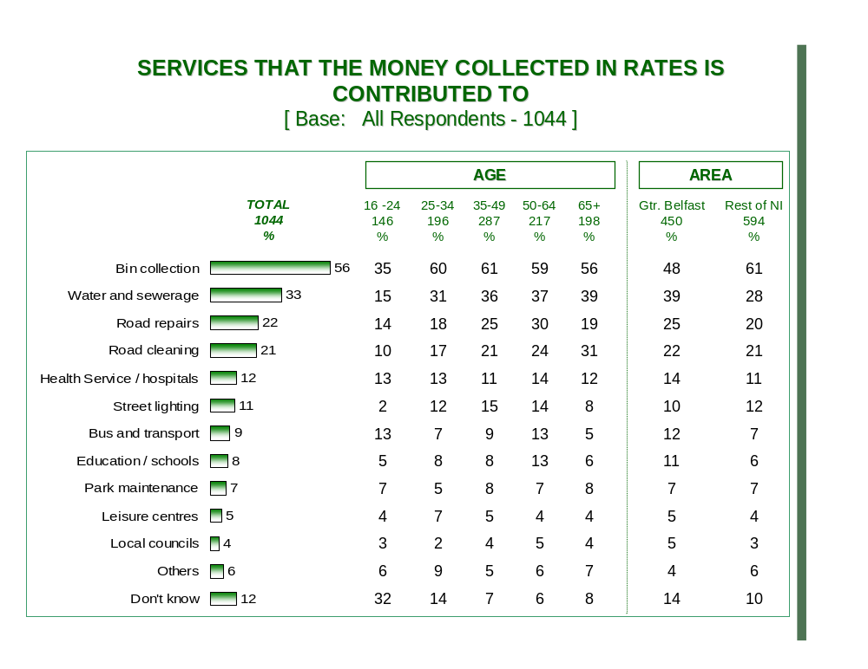

2. How to Pay for Public Services

- Almost two thirds agreed (63%) that those who use a public service more should have to pay more for it. This perception was slightly higher amongst males (67%), and those in the ABC1 (66%) and C2 (66%) socio-economic groupings. Under a quarter (22%) of respondents disagreed with this proposition.

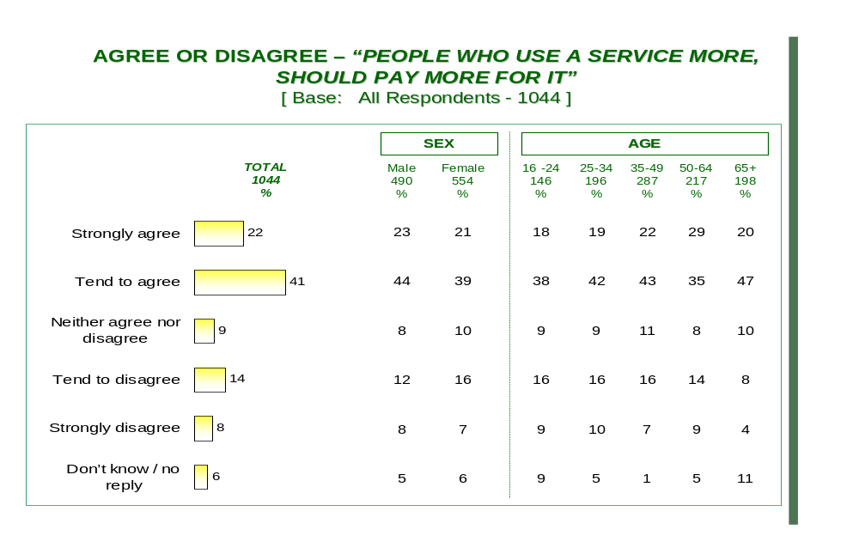

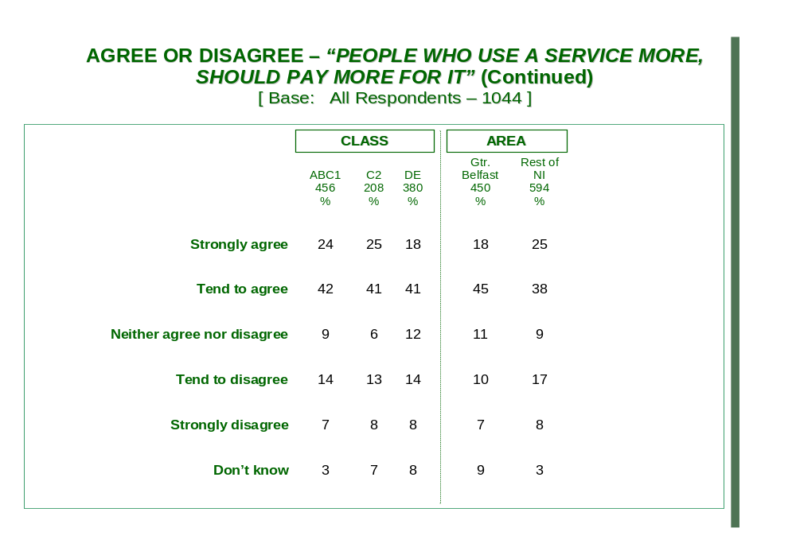

3. How Water Charges should be calculated

- Over 3 in 5 (61%) respondents stated that water and sewerage service charges should be calculated upon the amount of water used in each household (metering), as opposed to being based on the number in each household (12%), or indeed the value of the property (9%). The desire to calculate charges using a metering system were consistently high across all demographics, however was marginally more popular amongst ABC1’s (66%) and C2’s (60%), and those living outside Greater Belfast (63%).

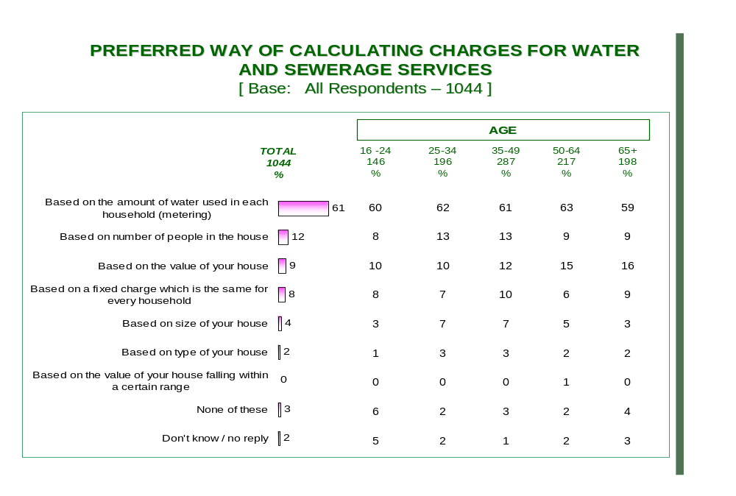

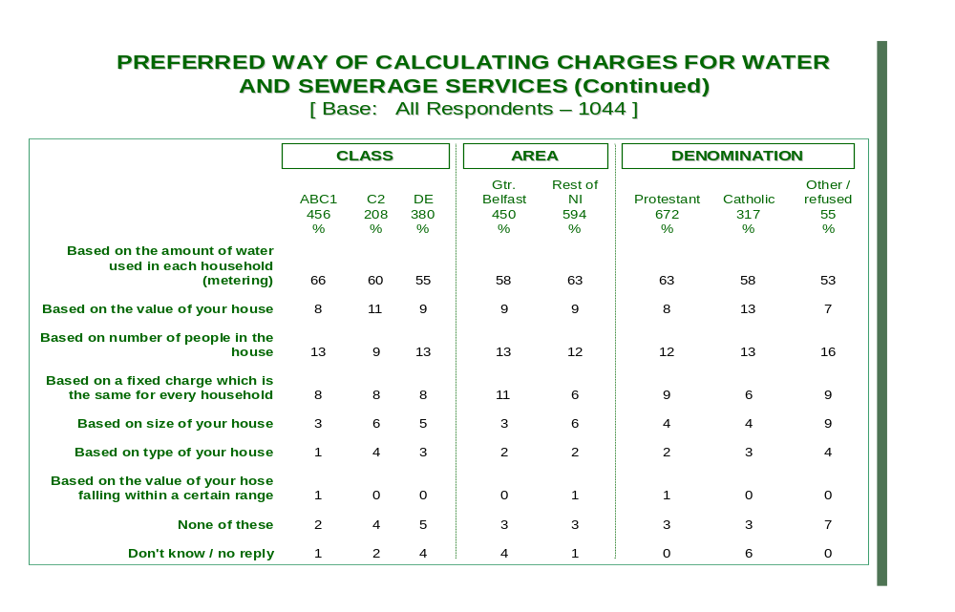

4. How People should pay for Water

- Over three quarters (77%) agreed that those who use most water, should pay the most, a belief more strongly felt amongst the older 50+ age category (83%), ABC1’s (81%), and those residing outside Greater Belfast (79%). Only 13% of respondents disagreed with this statement.

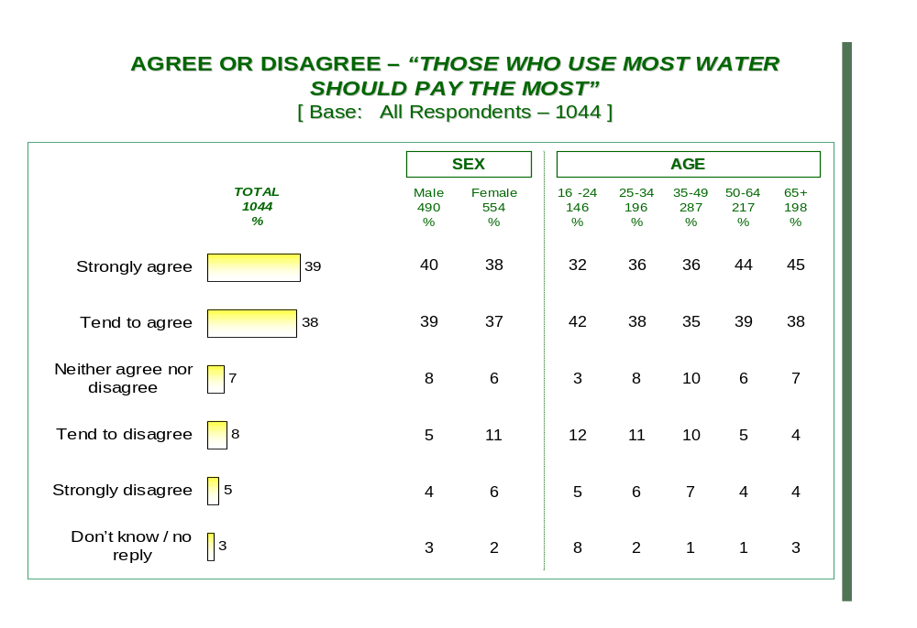

- Only 15% agreed that every household should pay the same regardless of the amount of water used. The vast majority (73%) disagreed with this proposition.
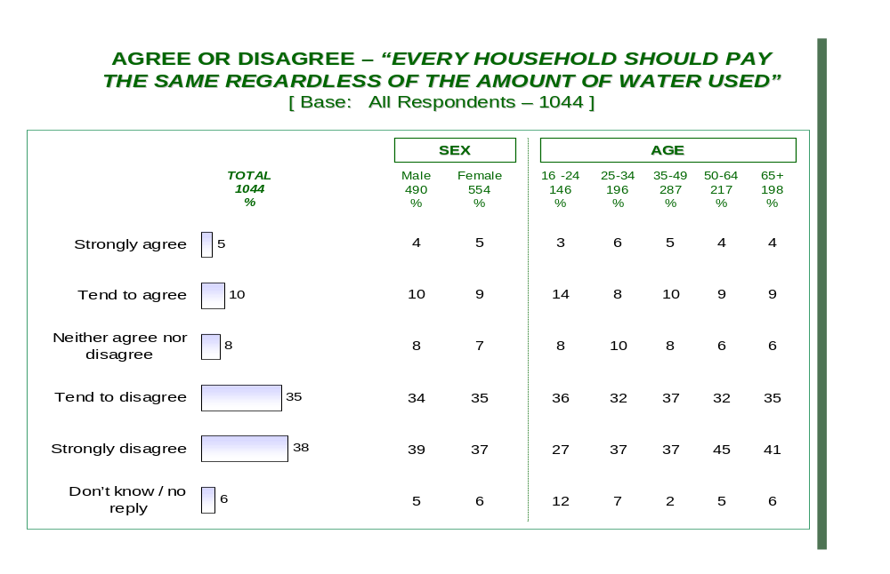

- Some 1 in 5 (20%) agreed payment should be based on the value of the property, however in sharp contrast, just under 3 in 5 (59%) disagreed with this.

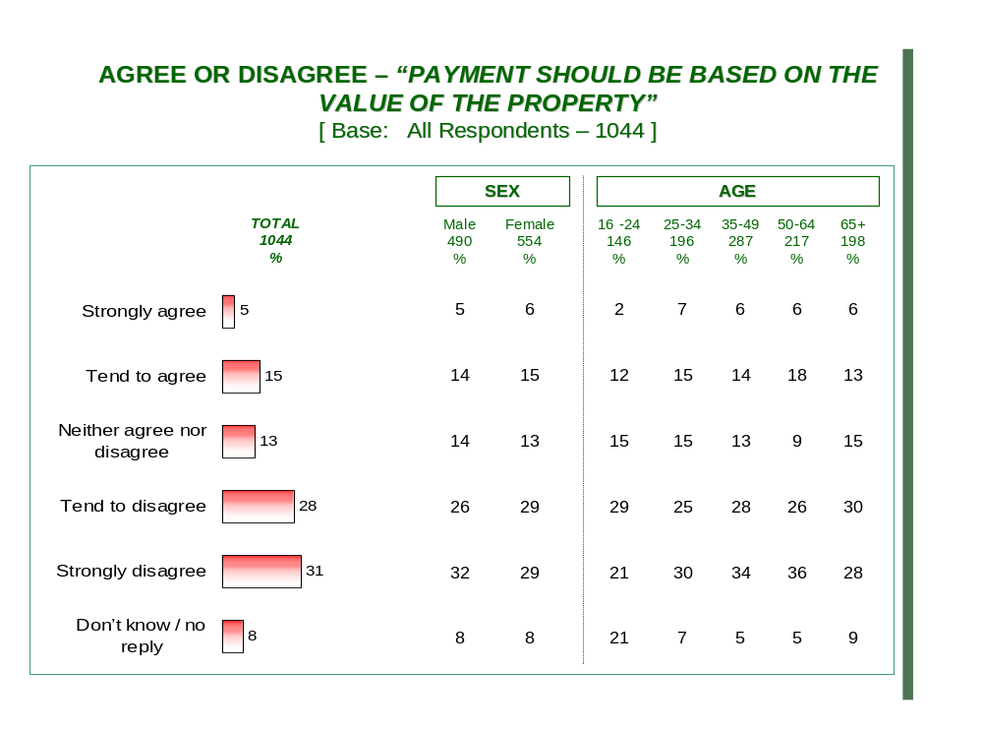

5. Protection for the vulnerable

- The elderly, over 65 (87%), those with health or medical conditions (35%), and households with low income (28%) who were regarded as being more entitled to special allowances.
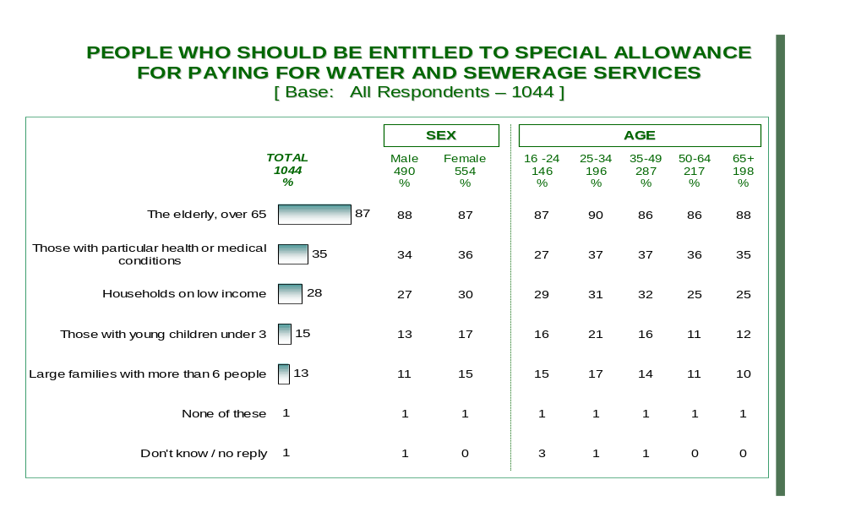

- We then asked if those who could least afford to pay should pay less. Interestingly, just under three quarters (72%) agreed that those who can least afford it should pay less, a sentiment which was more prevalent amongst the DE (78%) respondents.
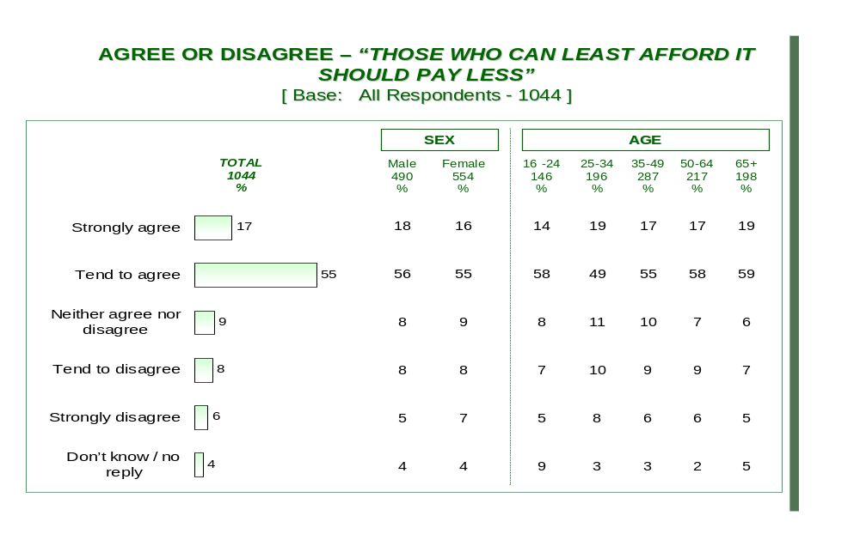

- This level of support however was not extended to the proposition that those who least can afford it should pay nothing, as just under a quarter (23%) agreed with this, compared to a half (50%) who disagreed. Those most likely to agree were from the DE socio-economic grouping (34%) and those residing within Greater Belfast (33%).

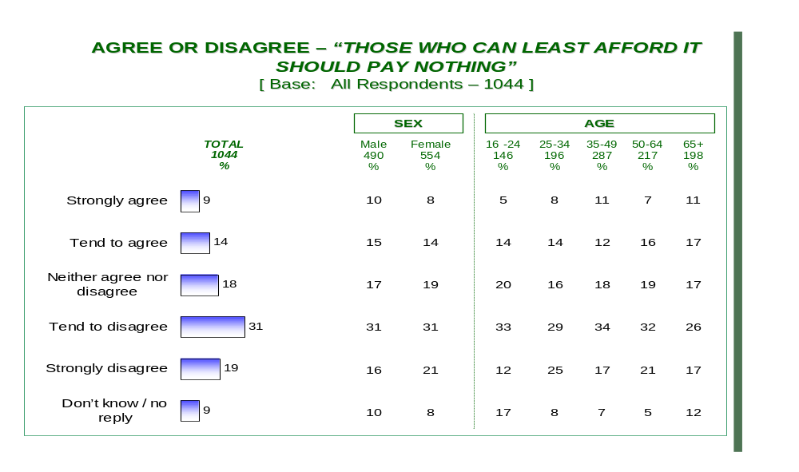

6. Funding of Discounts/Reliefs

- It was a strongly held view by most (65%) that government through the exiting benefit system, should be responsible for covering the cost of discount or relief schemes for water / sewerage. Over 1 in 10 (15%) however did prefer a new benefit scheme funded by central taxation.

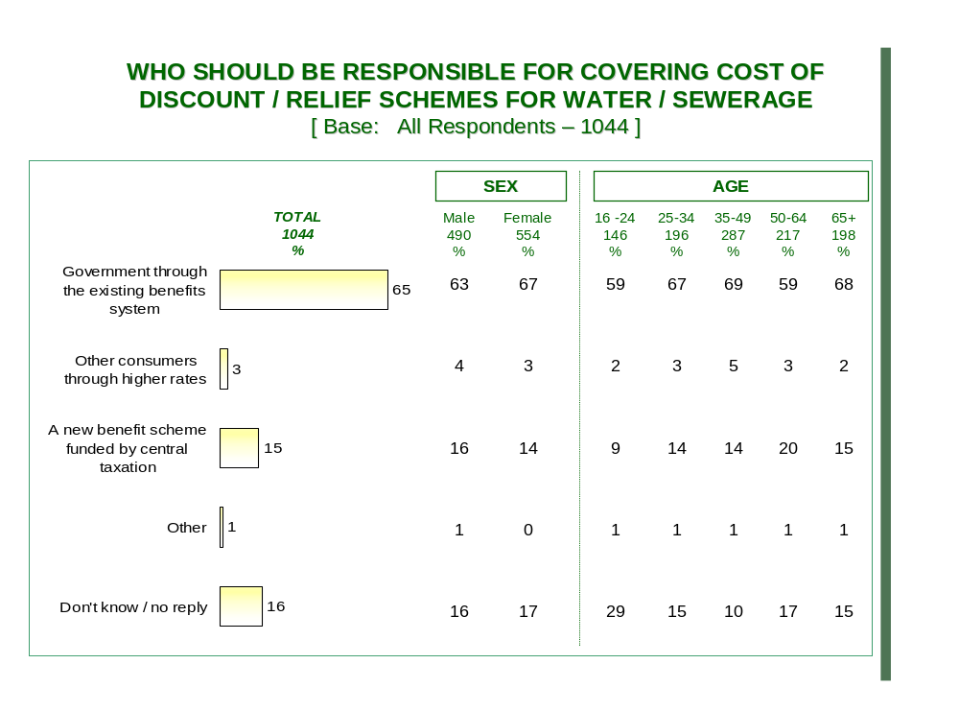

7. Conservation

- The final question on the survey set out to establish which payment method for water / sewerage services would most encourage respondents to conserve water. Almost 4 in 5 (77%) stated a payment method based on the amount of water used in each household (metering) would best achieve conservation, followed a long way behind by a calculation based on the value of the house (5%), and based on the number of people in the household (5%). Support for a metering system to encourage conservation was slightly more prevalent amongst ABC1’s (82%), and those residing outside Greater Belfast (82%).

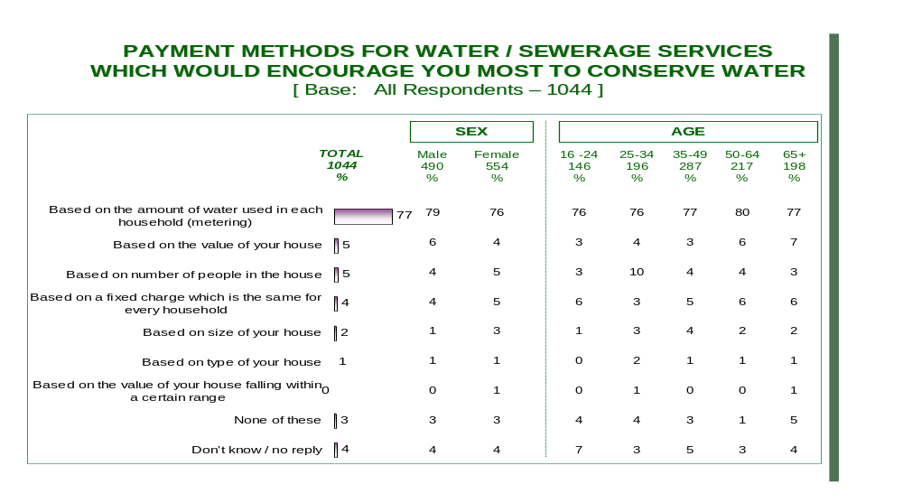

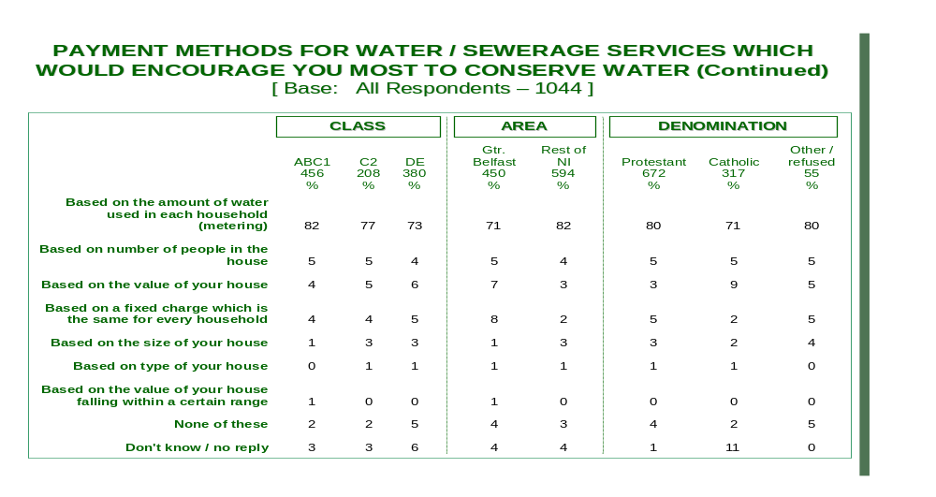

DRD Water Service, Water Resource Strategy 2002-2030, July 2002
DoE Water and Sewerage Services NI, a Consultation Paper.
GCCNI Water Survey, October 2004
www.ratecollectionagencyni.gov.uk
Derry City Council, ‘Understanding Your Rates 2004/05’, http://www.ratecollectionagencyni.gov.uk/council_info/Derry_Rates_explained.pdf
Debt, Charging and Social Impacts; A Water UK Think Tank, 19 May 2004.
OFWAT is the economic regulator for the water and sewerage industry in England and Wales.
OFWAT RD32/03 letter (28 August 2003) – Industry Information on Household Debt Levels and Debt Recovery Costs
Wessex Water figures, PUAF Conference, London 3 February 2005
Water Industry Debt – Socioeconomic and demographic effects, 2004
Economic and Social Research Council Seminar, Income Distribution and Poverty in Northern Ireland, Friday 4 February 2005
Correspondence from Department for the Environment, Food and Rural Affairs (DEFRA) to Martin Fitch, Public Utilities Access Forum (PUAF), 2004
Cross Government Review of Water Affordability Report, DEFRA, 2004
Maurice Terry, WaterVoice Chairman, WaterVoice Press Release, 9 November 2004
Pricing Water, OECD Environment Directorate March 2003
GCCNI Water Survey, October 2004
GCCNI Water Survey, August 2002
Robin Simpson, Consuming Water: Now and the Future. World Consumer Rights Day, Belfast, 15.03.04
Health and Health Services use in Northern Ireland: Social variations. O’Reilly D, Browne S.
{Douglas Black 2000 from Black D Working together for equity. Health Economics 2000, 9:567-8}.
In Poor Health, GCCNI, 2001
Northern Ireland Continuous Household Survey 2002-03
Health Impact Assessment of the Proposal to introduce Water Charges in Northern Ireland, Four Wards in the Ards Peninsula, Belfast Healthy Cities 2004
Ending Fuel Poverty: A Strategy for Northern Ireland, November 2004
Bare Necessities, OFMDFM commissioned report published by Democratic Dialogue 2005, Prof Paddy Hilyard and Prof Eithne McLaughlin.
Department of Finance and Personnel (July 2004) Reform of the Domestic Rating System in Northern Ireland.
Department for Regional Development press release (13.09.04) Minister Announces New Household Water Charges and Protection for Low-Income Households.
Water UK 2003-04
Water Industry Debt – Socioeconomic and Demographic effects, UKWIR, 2004
DEFRA website www.sustainable-development.gov.uk/sustainable/quality04/maind/04q03.htm
Regional Trends 2004, ONS
This assumes an even spread of households across each salary band.
Regional Trends 2004, ONS
This assumes an even spread of households across each salary band.
DRD Water Reform Unit website, www.waterreformni.gov.uk
National Consumer Council (November 2002) Towards a Sustainable Water Charging Policy
Ulster Farmers’ Union. Press Release 27.01.05. Farm Incomes Hindering Investment
Paragraph 3.39, The Reform of Water and Sewerage Services in Northern Ireland, A Consultation Document, March 2003
DRD Water Reform Unit, www.waterreformni.gov.uk
Joseph Rowntree Foundation (2004) Green Taxes and Charges
Joseph Rowntree Foundation (2004) Green Taxes and Charges
Joseph Rowntree Foundation (2004) Green Taxes and Charges
DRD Water Reform Unit figure based on an average house price of £112,000.
OFWAT ‘Future Water and Sewerage Charges, 2005-2010 - Final Determinations’ and WaterVoice
OFWAT ‘Future Water and Sewerage Charges, 2005-2010 - Final Determinations’ and WaterVoice
GCCNI Water Reform – Assessment of Resources, ASM Horwath Report (25 January 2005)
Department of Finance and Personnel (July 2004) Reform of the Domestic Rating System in Northern Ireland
EU Water Framework Directive (October 2000)
Department for Regional Development press release (13.09.04) Minister Announces New Household Water Charges and Protection for Low-Income Households
Department for Regional Development press release (13.09.04) Minister Announces New Household Water Charges and Protection for Low-Income Households
General Consumer Council (May 2003) Paying for Water: A General Consumer Council Information Paper
Joseph Rowntree Foundation (June 1997) Social Policy Research 115 - Paying for Household Water Services
Department for Regional Development (March 2003) Reform of Water and Sewerage Service in Northern Ireland: A Consultation Document
Department for Regional Development (March 2003) Reform of Water and Sewerage Service in Northern Ireland: A Consultation Document
General Consumer Council (May 2003) Paying for Water: A General Consumer Council Information Paper
National Consumer Council (November 2002) Towards a Sustainable Water Charging Policy
Department for Regional Development press release (13.09.04) Minister Announces New Household Water Charges and Protection for Low-Income Households
National Consumer Council (November 2002) Towards a Sustainable Water Charging Policy
OECD Sustainable Water Use in Europe
EU Water Framework Directive (October 2000)
Water Service (2004) Annual Report and Accounts 2003/04
Department of Finance and Personnel (July 2004) Reform of the Domestic Rating System in Northern Ireland
Department for Regional Development press release (13.09.04) Minister Announces New Household Water Charges and Protection for Low-Income Households
Watervoice (July 2004) quoting UK Water Industry Research
National Consumer Council (November 2002) Towards a Sustainable Water Charging Policy
National Consumer Council (November 2002) Towards a Sustainable Water Charging Policy
Which? Online. Water Meters
General Consumer Council (May 2003) Paying for Water: A General Consumer Council Information Paper

